Barbara Ann (Duhe) Edler
February 22, 1942 - May 13, 2017

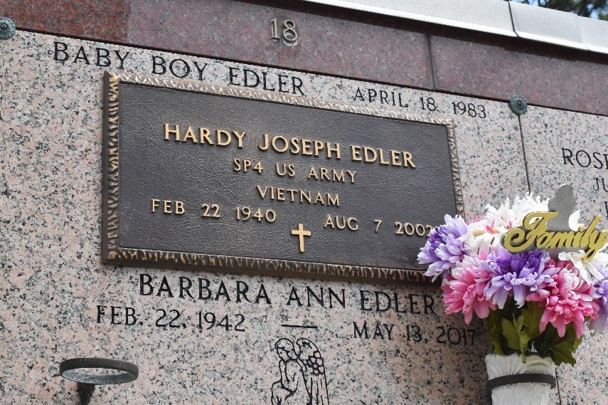

Barbara Duhe Edler Champagne passed away on Saturday, May 13, 2017, at the age of 75.
She was a life long resident of Reserve and retired from Saint Peter Catholic School in Reserve as a pre-school assistant teacher. She was the beloved wife of her first husband, the late Hardy J. Edler, and then her second husband, the late Herbert Champagne Sr.
She was the loving mother of Ched Edler and wife Tina, Kevin Edler and fiance’ Catherine, and Ron Edler and wife Carla; grandmother of Ched (CJ) Edler Jr., Shane Edler, Dane Edler, Hayden Edler and Jonathan Harris; stepmother of Herbert Champagne Jr. and Shane Champagne and husband Doug; daughter of the late Maurice Duhe, Lucette William Duhe and the late Violet Boudreaux Duhe; and sister of Gloria Fay LeBlanc and husband Carroll, Vernon Duhe and wife Pearl Ann and the late Ronald Duhe and wife Janet.
Relatives and friends of the family are invited to attend the Funeral Mass at St. Peter Catholic Church, 1550 Highway 44 in Reserve on Wednesday, May 17 at 12:30 p.m. Visitation will begin in the church at 10:30 a.m. Interment will follow in St. Peter Cemetery. Arrangements are by Millet-Guidry Funeral Home.

L’Observateur, LaPlace, Louisiana
Monday, May 15, 2017

