Hardy Joseph Edler
February 22, 1942 – May 13, 2017

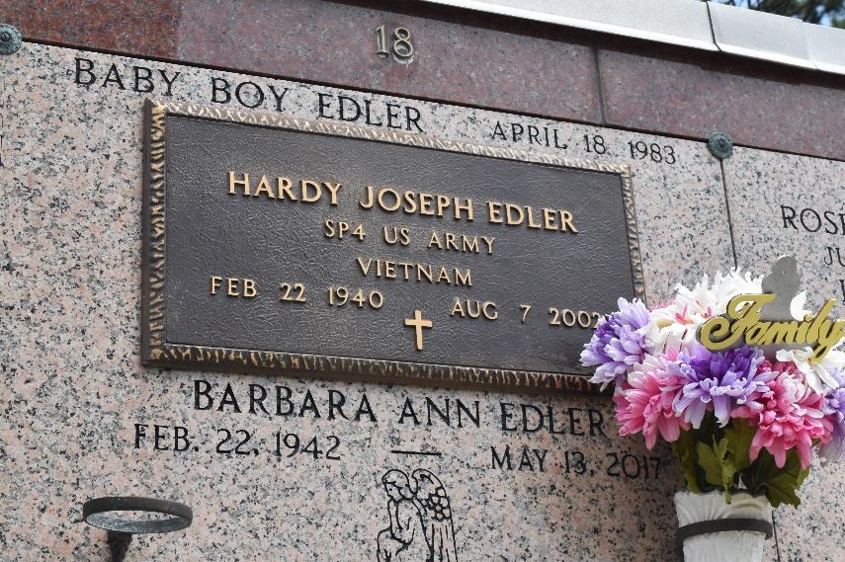

LAPLACE – Hardy Joseph Edler, 62, a resident of Reserve for 62 years, died Aug. 7.

He was the husband of Barbara Duhe Edler and father of Ched, Kevin and Ron Edler. He was the son of the late Clinton Sr. and Malde Madere Edler and brother of Marilyn Acosta, Janice McTopy, Clinton Jr. “C.J” and Mickey Edler. He is also survived by four grandchildren.

He was a U.S. Army Veteran and a produce manager for 42 years, employed at Frank's Supermarket in LaPlace.

Services were August 9th in the chapel of Millet-Guidry Funeral Home, LaPlace, with interment at St. Peter Cemetery, Reserve, LA

L’Observateur, LaPlace, Louisiana
Tuesday, August 13, 2002

