Maurice Price Edler Jr.
July 16, 1830 – May 3, 1911

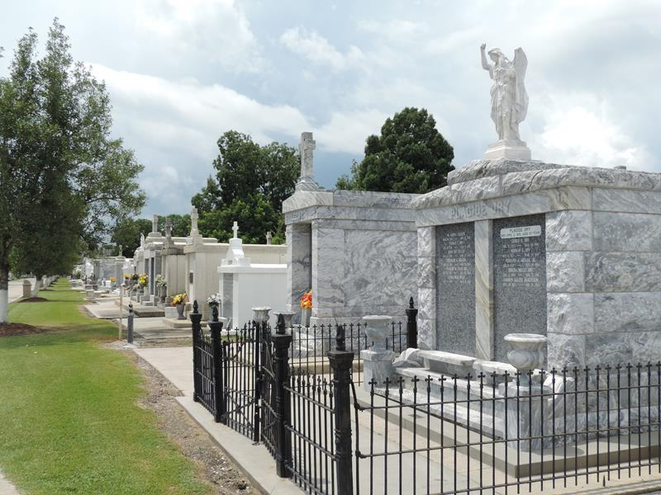

Death of Prominent Planter and Citizen
On Wednesday morning, at 2 o'clock, Mr. Morris Edrington, aged eighty years and nine months and seventeen days, died at his home in this parish, after an illness of several weeks. Mr. Edrington was the head of one of the oldest and most prominent families in St John. Deceased was born here and received his educational training in Missouri. At an early age he engaged in the planting business and, for several years, was overseer and manager on the Carroll and Terre Haute plantations.
Mr. Edrington was a Confederate veteran, and throughout the war he served as Lieutenant under Colonel W. W. Freret, with credit and honor. After the long conflict, Mr. Edrington purchased the Cornland sugar plantation, near Reserve, and he was known as one of the most successful planters of the upper coast. The product turned out by the Cornland sugar house was unequaled in purity and the owner was particularly proud of his syrup. Its reputation, due to Mr. Edrington's judicious management, had gone beyond the confines of Louisiana and this table delicacy was known favorably in Washington, DC, and in many Northern cities.
Mr. Edrington served for many years as president of the Police Jury. As one of the best known citizens in St John, Mr. Edrington was loved and esteemed for his kind and noble impulses. He was unselfish and charitable to a fault, a kind and gentle father and a warm and true friend. In his death the parish loses another citizen of the old school, one we would have liked to keep with us longer and one we could ill afford to spare. With a splendid physique and a rugged constitution, Mr. Edrington still gave promise of a longer lease of life. Youth seemed to linger with him and his wonderful vitality was often commented upon by his friends. It was our good fortune to have known Mr. Edrington. He had a pleasant smile and warm greeting for all, of whatever station in life. He was an optimist and always saw something in life worth living for.
The deceased is survived by two sons, Judge Prentice E. Edrington, of the Twenty-eighth Judicial District Court and Morris Olivier Edrington, of Reserve, together with sixteen grandchildren and two great-grand-children, and a large number of relatives.
The funeral services were held on Thursday morning, at 10 o'clock, at St. Peter's Catholic Church, Father Badeaux officiating. The Church was filled with sorrowing relatives and friends, many coming from far to pay homage to the memory of one near to their hearts. Father Badeaux extolled the virtues and industry of the departed and referred to his life as a model worthy of emulation. Halimah Tribe, No. 101, Independent Order of Redmen, of Reserve, as a feeble testimonial of gratitude for many favors received, had thoughtfully ordered a beautiful wreathe of flowers which covered the casket.
To the bereaved family the 'Mesehacebe" proffers its sincere expressions of sympathy and condolence.
Le Meschacebe, Lucy, Louisiana
6 May 1911, p. 1

