Maize (Bardell) Edwards
1915 – February 3, 2000

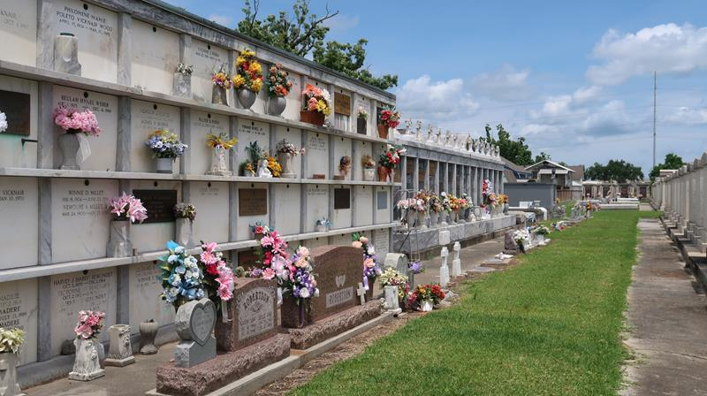

Maize 'Mae' Bardell Roussell Edwards Departed This Earthly Life And Entered Into Eternal Rest On Thursday, February 3, 2000 At 6:05 Am. At East Jefferson General Hospital, Metairie, La.
Beloved Wife Of Welmen Edwards, Sr. Dearly Loved Mother Of Marie Joseph, Junius Roussell, Jr., Ronald Roussell, Eugene (Gene) Roussell, All Of Mt. Airy, La. Zenobia Taylor, John Roussell Of Reserve, La., Veronica Joseph Of Laplace, La And The Late Georgianna Rixner. Step-Mother Of Welmen Barry Edward, Jr. And Barbara Taylor. Daughter Of The Late Edgar, Sr. And Ophelia Bardell. Sister Of The Late Georgianna Stewart, Eugene, Clifford, Herbert, Edgar, Freddie And Nathaniel Bardell. Also Survived By 45 Grandchildren, 68 Great Grandchildren And 9 Great Great Grandchildren, A Host Of Nieces, Nephews Other Relatives And Friends. Age 85 Years.
Relatives And Friends Of The Family, Also Priest And Parishioners Of St. Hubert Catholic Church, Employees Of Stockhausen, Ltd., Nalco Chemical Co., Gorden's Of Kenner Establishment, Kaiser Aluminum And All Neighboring Churches Are Invited To Attend The Mass Of Christian Burial On Monday, February 7, 2000 At 10:00 A.M. At The St. Hubert Catholic
Church, 176 Anthony Monica St., Garyville, La. No Wake. Father Clauda S.S.J. Celebrant. Visitation Will Be At Bardell's Mortuary Of Mt. Airy From 8:00 A.M. To 9:00 A.M. And At St. Hubert Catholic Church From 9:00 A.M. Until Service Time. Interment In St. Peter Cemetery. Reserve, La. Bardell's Mortuary In Charge.

Unknown source

