Charles Maurice Elfer Sr.

March 13, 1851 – February 5, 1927

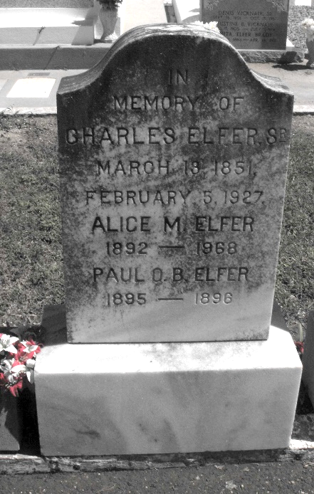

Photo by Mary Agnes Hammett

Planter and Political Leader Died in Hospital.

Charles Elfer, 76 years old, of St Rose, Louisiana, member of a well-known Southern Louisiana family, a lifelong resident and planter in this part of the state, and for many years a figure in the political affairs of the common-wealth, died early Saturday morning at the Baptist hospital here [New Orleans], after an illness of several months. Members of his family were at the bedside.  
 The funeral will take place at 10 o'clock Sunday morning from Bultman's undertaking place, 2911-21 Magazine Street. Interment will be at Reserve, Louisiana, Sunday.  
 Mr. Elfer was born March 15, 1851, in the parish of St John the Baptist. He was the son of Sylvestre Octave Elfer, and a descendant of some of the first settlers of the coast along the Mississippi river, in the parishes of St John and St Charles. After the Civil War he engaged in merchandising and later bought the Modoc Plantation in St. Charles Parish, moving from there to St. Rose. Governor Foster appointed him assessor of St. Charles, an office he held for sixteen years. He was a member of the school board of St. Charles and served as president of the police jury of St. Charles, representing the Fifth Ward, and also served as member of the St. Charles Parish Democratic executive committee.  
 Charles Elfer married Miss Catherine Devienne Desnoyer, of St. John parish, who died in 1884. He was married again in 1888 to Miss Alice Marguerite Thompson of St. Gabriel. He leaves three sons by his first wife, Maurice, Octave and W. Andre, and by his second wife, who survives him, six children, L. Gus, Eugene H., John, Miss Alice, and also two other daughters, Mrs. Clara Miller of Cleveland, Ohio, and Mrs. Felicie Young of St. Rose. He also is survived by a sister, Mrs. Octavie Bossier, of Sellers, and a number of grandchildren and other relatives.  
 Mr. Elfer was a member of the order of Elks and had a large number of acquaintances in this city.

The Times-Picayune, New Orleans, Louisiana

6 Feb 1927