Gladys (Vicknair) Elfer
August 26, 1948 – December 7, 2017

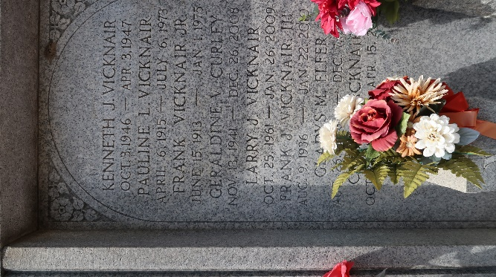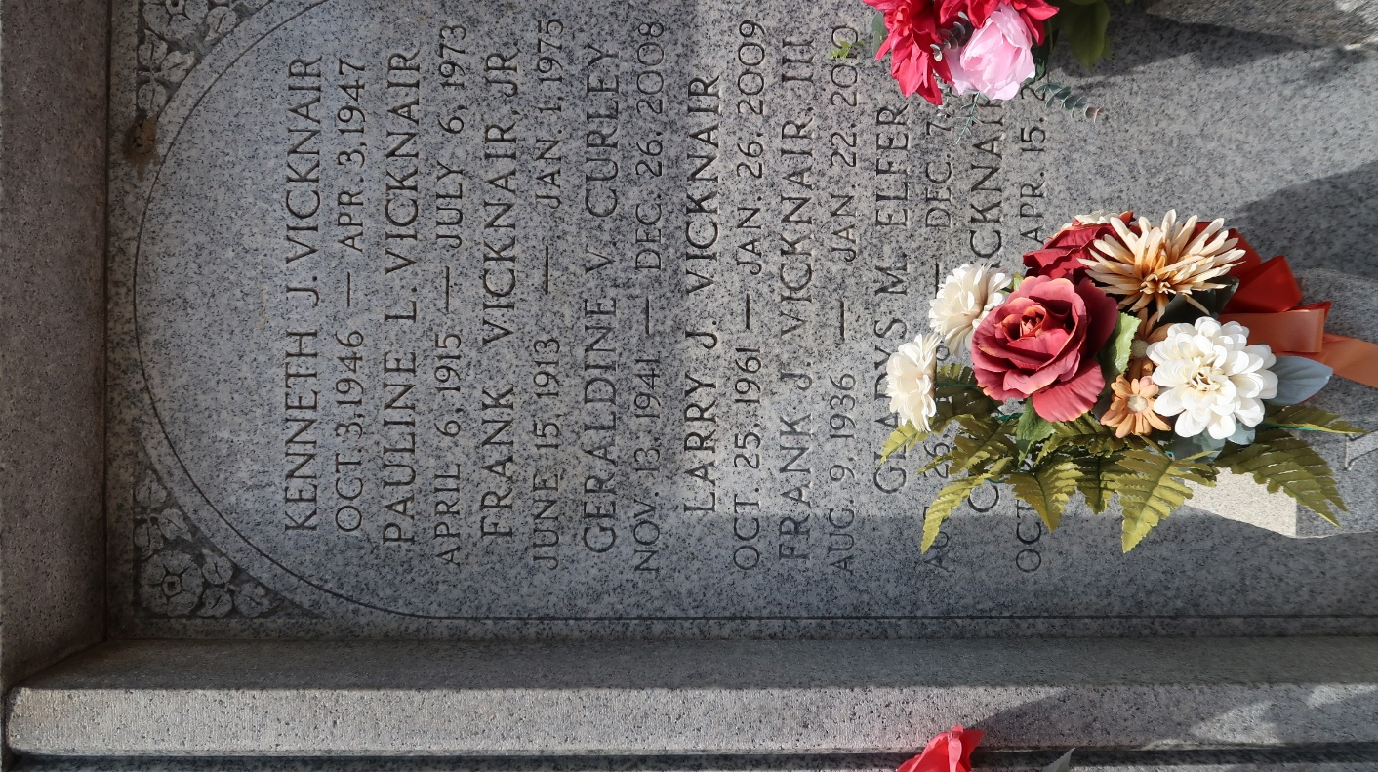

Gladys Vicknair Elfer passed away on Thursday, December 7, 2017 at the age of 69. She was a native of LaPlace and a resident of Reserve, LA.
Beloved wife of the late Lyle F. Elfer. Loving mother of Lori Lynn Elfer (Ryan Dolive) and Jason Elfer. Grandmother of Madison Francis Dolive. Daughter of the late Frank and Pauline LaBranche Vicknair. Sister of Gerald Vicknair (Carol), Gary Vicknair (Jeannie) and the late Frank Vicknair (Hilda), Floyd Vicknair (Carol) and Geraldine V. Curley. She is also survived by nieces and nephews and her good friend, Toni Sanchez.
Relatives and friends are invited to attend the Visitation at Millet-Guidry Funeral Home, 2806 W. Airline Hwy, LaPlace on Thursday, December 14, 2017 from 11:00 a.m. to 1:00 p.m. and the Funeral Mass will immediately follow at St. Peter Catholic Church, 1550 Hwy 44, Reserve, LA at 1:30 p.m. Interment in St. Peter Cemetery.
Millet-Guidry Funeral Home, LaPlace, Louisiana
12/10/2017

