Paul Optime B. Elfer

August 5, 1895 – May 1, 1896

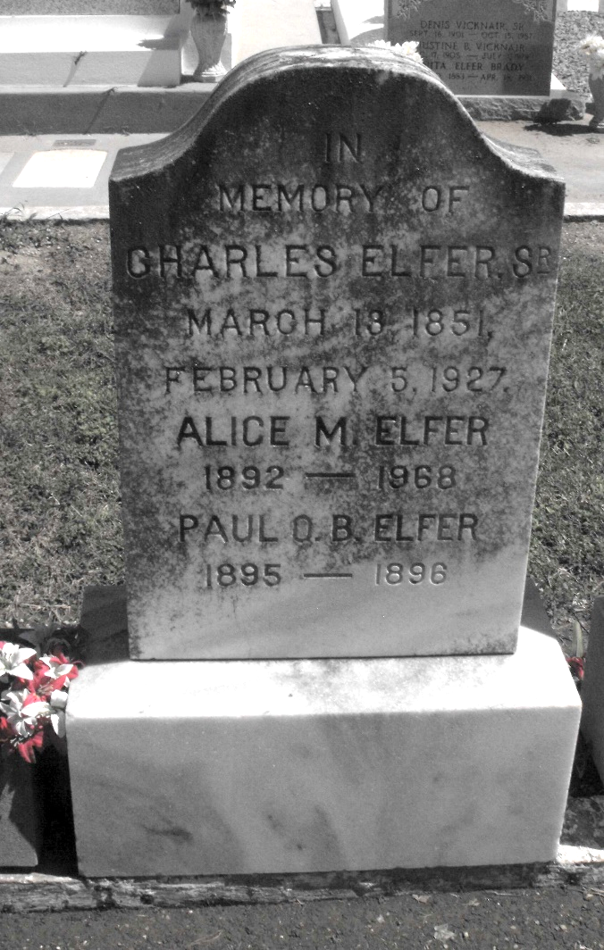

Photo by Mary Agnes Hammett

ELFER - On Thursday, April 30, 1896, at 10:45 p. m., PAUL B. O. ELFER, infant son of Charles Elfer and Alice Thompson, aged 9 months.

Friends and acquaintances are respectfully invited to attend the funeral, which will take place at St. Peter's Church, in the parish of St. John, Friday, May 1.

The Times-Picayune, New Orleans, Louisiana

May 1, 1896