Clara Amanda (Kittrell) Englade

December 18, 1909 – December 30, 2002

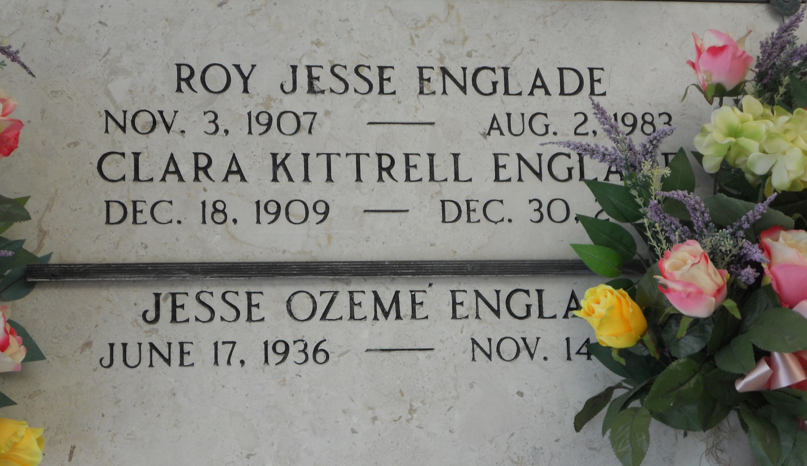

Photo by Team T-Lo

Clara K. Englade On Monday, December 30, 2002 At 4 Pm.

Beloved Wife Of The Late Roy Englade. Mother And Mother-In-Law Of Evelyn And Lin Sutton, Betty And Norval Pitre, Lynda And Wilbur Smith, And The Late Jesse Englade. Also Survived By 12 Grandchildren, 14 Great-Grandchildren, And 3 Great-Great- Grandchildren. Age 93 Years. A Native Of Mississippi And A Resident Of Reserve, La. For The Past 75 Years.

Relatives And Friends Of The Family Are Invited To Attend Services. Visitation At Millet-Guidry Funeral Home, 2806 West Airline Highway, Laplace, La. On Thursday, January 2, 2003 From 5 Pm Until 10 Pm And On Friday From 8 Am Until 9:45 Am Followed By Religious Services At St. Peter Catholic Church, Reserve, La. At 10 Am. Burial At St. Peter Cemetery, Reserve, La.  
  
  
The Times-Picayune, New Orleans, Louisiana

January 1, 2003