Jesse Ozeme Englade

June 17, 1936 – November 14, 1992

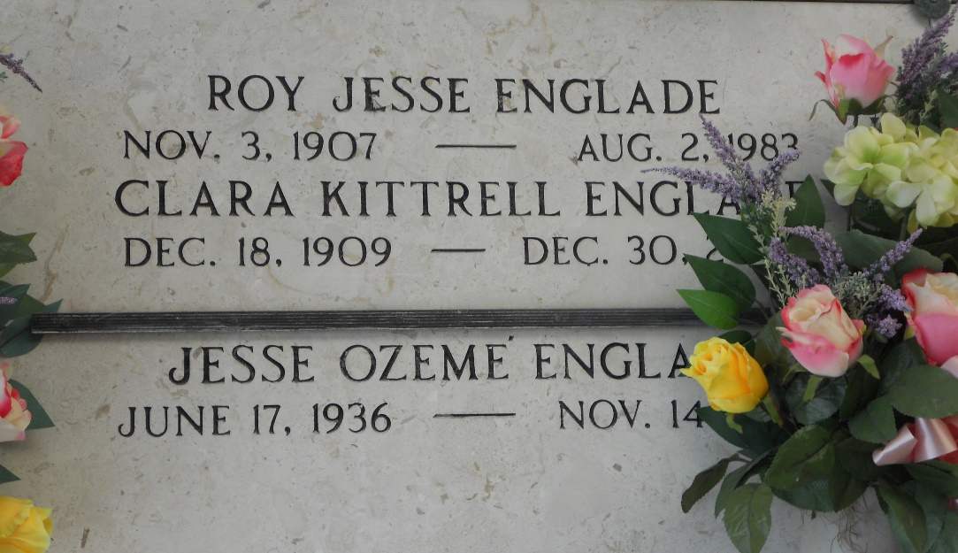

Photo by Team T-Lo

Jessie Ozeme Englade, An Electrical Design Engineer for Texas Instruments, Died Saturday of Cancer in Plano, Texas.  
 He Was 56. Mr. Englade Was Born in Reserve, La., And Lived in Plano.  
 Survivors Include His Wife, Barbara Englade; Two Sons, Christopher D. And Mark Alan Englade; His Mother, Clara Kittrell Of Reserve; Three Sisters, Evelyn Sutton of Reserve, Betty Pitre of Montegut, La., And Lynda Sue Smith of Fairburn, Ga.  
 Visitation Will Be Today From 6 To 9 P. M. At Ted Dickey Funeral Home in Plano. A Mass Will Be Said Wednesday at 10 A. M. At St. Marks Catholic Church in Plano. Burial Will Be in Calvary Hill Memorial Park in Dallas.  
  
The Times-Picayune, New Orleans, Louisiana

November 17, 1992

This is a cenotaph. Remains buried in Patio Mausoleum in Calvary Hill Cemetery, Dallas, TX.