Olga (Scioneaux) Englade

December 27, 1927 – May 17, 2019

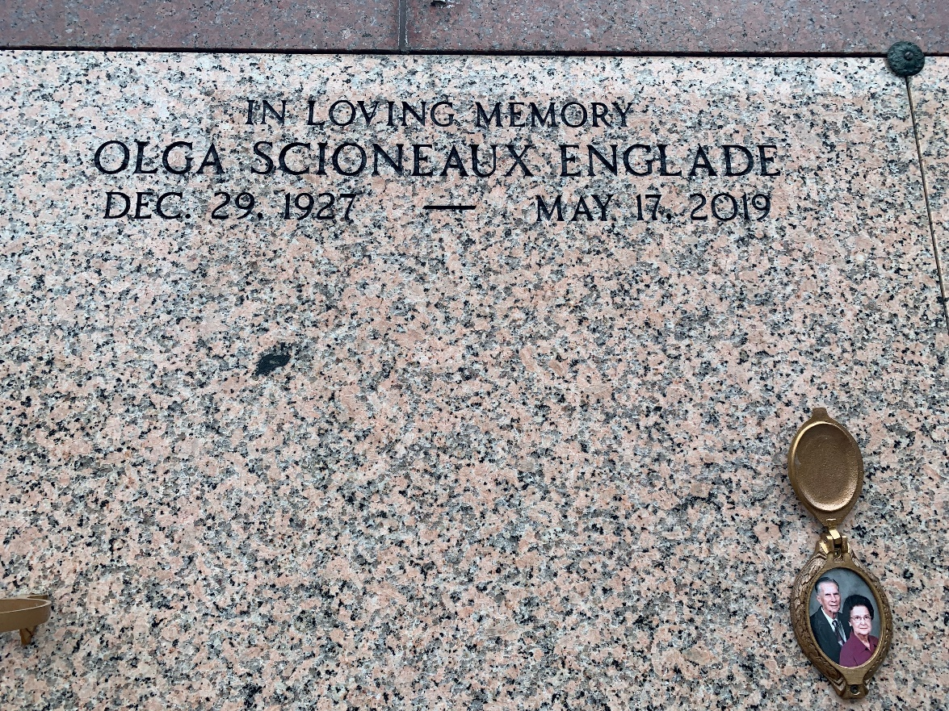

Photo by Team T-Lo

Olga Scioneaux Englade passed away on Friday, May 17, 2019, at the age of 91. She was a native and longtime resident of Reserve, La., and recently resided in Baton Rouge. She was a parishioner of St. Peter’s Catholic Church and a member of the Ladies Altar Society and Catholic Daughters.

She was the beloved wife of the late Norman Louis Englade, Sr. She was preceded in death by her parents Wilson and Eva Mury Scioneaux and her siblings Wilson “Toot” Scioneaux, Jr.; Edwin Scioneaux; Nelva S. Oncale; and Alice S. McGuire.

She is survived by her sister Hazel S. Roche, who resides in Springfield, Va.; her daughter Margaret Englade Webb and son-in-law David Webb of Baton Rouge; her son Norman L. Englade, Jr. and daughter-in-law Libby Mollere Englade of Reserve; her five grandchildren, Andrew Webb, Christie Englade, Erica Englade, Halie Englade, and Sadie Englade; as well as many nieces and nephews  
 Relatives and friends are invited to attend the funeral mass at St. Peter Catholic Church, 1550 Hwy 44, in Reserve, on Thursday, May 23, 2019 at 11 a.m. Visitation will be held at the church from 9 a.m. to 11 a.m., followed by mass and interment at St. Peter’s Cemetery.

Millet-Guidry Funeral Home, LaPlace, Louisiana