Marie Louise (Jacob) Entremont

December 31, 1929 – May 7, 2022

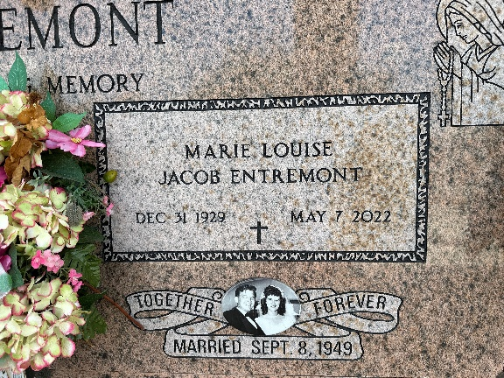

Photo by Team T-Lo

Marie Louise "Tock" Jacob Entremont passed away peacefully at her home on May 7, 2022. Born on December 31, 1929. She was a lifelong resident of Reserve, Louisiana. Born to the late Odile and Felix Jacob. She married the love of her life the late Maurice James Entremont, Jr.

Loving mother of Joel Entremont (Arlene Madere), Mark Entremont (Cheryl Maquar), Suzanne Entremont Cancienne (Brian Cancienne) and the late Gregory Entremont (Cheryl Clement). She is survived by her grand-children, Yvonne, Gary, Joey, Brian, Kelley, Jason, David, Julie and Brian Cancienne, Jr. and 11 great grandchildren. Sister of Felix "Joe" Jacob (Pat) and Malcolm "Nonnie" Jacob (the late Agnes Marse). Also survived by nieces and nephews.

Tock loved spending time with her family and friends. She loved to "laissez-les bons temps roulon" especially at LSU football games and Mardi Gras parades and family celebrations.

The family would like to give a special thanks to her caretakers, Lynn Temple and Kitty Bradford and the staff of Heart of Hospice.

Relatives and friends are invited to attend the Service. A Funeral Mass will be celebrated at St. Peter Catholic Church, 1550 Hwy 44, Reserve on Thursday, May 12, 2022 at 11:00 a.m. Visitation will be held from 9:00 a.m. to 11:00 a.m. Interment in St. Peter Cemetery, Reserve, LA. In lieu of flowers, please consider Masses.

Millet-Guidry Funeral Home, LaPlace, Louisiana

May 10, 2022