Nicole Marie Entremont
December 19, 1981 – November 24, 2017

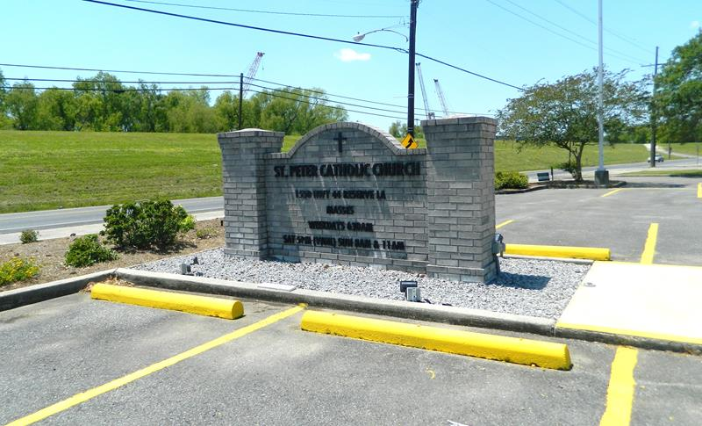
Photo by Team T-Lo

Nicole Marie Entremont, was born on December 19, 1981 and passed away on November 24, 2017 at the age of 35. She was born in New Orleans and was a lifetime resident of Garyville.
She is survived by her parents, Glynn and Gwen Roccaforte Entremont; sons, Gage Frank Descant, and Ryder Michael Kliebert; brother, Jarrett Michael Entremont (Hailey); niece, Addison Entremont; nephews, Grayson, Lawson, and Emerson Entremont; aunts, Susie Louque (Mark) and Jessica Entremont; Godfather, Barry Roccaforte (Tanya) and Godmother, Deanie Samrow.
She was preceded in death by her grandparents, Frank and Frances Roccaforte and Herman Entremont and Jeanne Entremont Bigelow as well as an uncle, Barry Entremont.
The family would like to give special thanks to St. Elizabeth’s Hospital, Ochsner Main Campus, and Amedisys Hospice.
A visitation in her honor will be on Friday, December 1, 2017 from 9:00 a.m. until a Mass of Christian Burial at 11:00 a.m. at St. Hubert Catholic Church in Garyville, LA followed by interment in St. Peter Cemetery in Reserve, LA.

ROSE LYNN FUNERAL HOME, Lutcher, Louisiana

