Thomas P. Erwin

February 29, 1944 – October 4, 2013

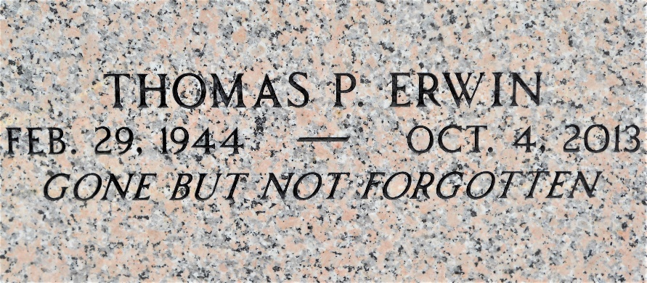

Photo by Team T-Lo

Thomas P. Erwin died on Friday October 4, 2013.

Beloved son of the late Thomas and Louise Maus Erwin. Brother of Patrick I. Erwin and the late Peggy J. Mumphrey . Age 69. A native and resident of LaPlace, LA.

Relatives and friends are invited to attend services. Visitation at Millet-Guidry Funeral Home, 2806 W. Airline Hwy., LaPlace, LA on Monday, October 7, 2013 from 8:30 am to 10:30 am, followed by Mass in the Funeral Home Chapel at 10:30 am. Burial in St. Peter Cemetery, Reserve, LA.

The New Orleans Advocate, Louisiana

Oct. 5 to Oct. 6, 2013