Albertine (Johnson) Etienne
August 14, 1932 – June 28, 2011

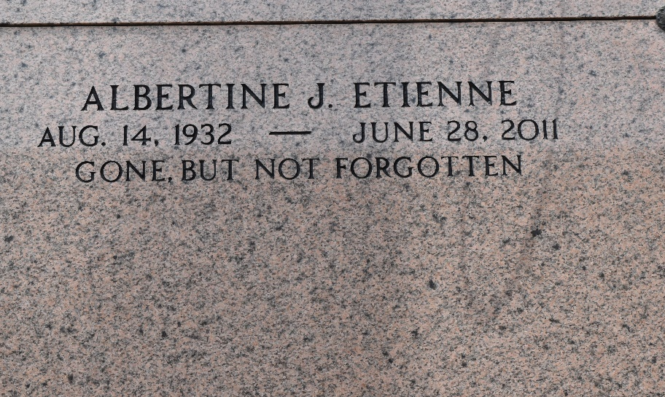

Albertine Johnson Etienne on Tuesday, June 28, 2011 at River Parish Hospital, LaPlace, LA.
Daughter of the late Thelma Humphrey and Alfred Johnson. Wife of the late Charles A. Etienne. Sister of the late Theresa Lawrence, Geraldine LeBoyd, Caroline Weston, Billie Mae Henderson and Dorothy Sumler. Also survived by 5 godchildren, and a host of nieces, nephews, other relatives and friends. Age 78 years. A native of Reserve, LA and a resident of LaPlace, LA.
Relatives and friends of the family, also pastors, officers and members of Bethlehem Baptist Church and all neighboring churches and St. John the Baptist Parish School System are invited to attend the funeral at Bethlehem Baptist Church, 147 East 20th Street, Reserve, LA on Saturday, July 2, 2011 at 10:00 AM. Pastor Forell Bering, Officiating. Interment St. Peter Cemetery, Reserve, LA. Visitation at the above named church from 8:00 AM until service time. SERVICED BY ROBOTTOM

The Times-Picayune, New Orleans, Louisiana
Jul. 1, 2011

