Rt. Rev. Msgr. Jean M. Eyraud

November 11, 1880 – February 5, 1968

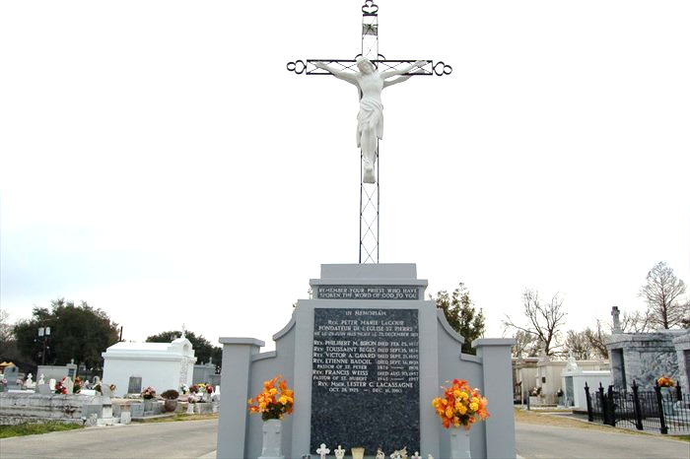

EYRAUD – On Monday, Feb. 5, 1968, at 11:30 o’clock a.m., Rt. Rev. Msgr. Jean M. Eyraud, Pastor Emeritus of St. Peter Church, Reserve, La.; son of the late Zozine Eyraud and Marie Gonsolin; uncle of Mrs. Helene Brochier and Mrs. Jeanette Seibert; aged 87 years; a native of Hautes Alpes, France and a resident of Reserve, La., for the past 51 years.

Parishioners of St. Peter Parish and Parish Societies, Friends, Priests and Archdiocese of New Orleans and Diocese of Baton Rouge, La., and religious are invited to attend the services. Mass for school children on Tuesday, Feb. 6, 1968 at 10:30 o’clock a.m. at St. Peter Church, Reserve, La. Remains will lie in State in St. Peter Church from then until burial Mass at 10:30 o’clock a.m. Wednesday, Feb. 7, 1968. Interment St. Peter Cemetery. Contributions to Msgr. J. Eyraud Seminary Burse preferred to flowers.

St. Peter Council No. 2436 Knights of Columbus, Reserve, La., officers and members of this Council are requested to attend the funeral of our late brother, Msgr. Jean M. Eyraud, on Wednesday, February 6, 1968, at 10:30 o’clock a.m., at St. Peter Church, Reserve, La., recitation of the Rosary on Tuesday night, at 9 o’clock at St. Peter Church.

By Order of N. Delanezille, Grand Knight.

Attest: Alexis Millet, Secretary

Unknown, undated newspaper clipping

\*\*\*\*\*

The Servant of God, Rt. Reverend Monsignor Jean Martin Zozine EYRAUD was born in Le Glaizal, France on the Feast of St. Martin de Tours, November 11, 1880; son of Zozine Eyraud and Frances Gonsonil-Chevillon. Educated at the Rondeau in Grenoble, France and at the Major Seminary in Gap, France. Ordained to the Holy Priesthood at Gap on June 29, 1904. Military service: Twenty-second Infantry Regiment as a private, for one year. Arrived in America in June, 1910. First pastorate: St. Thomas, Pointe-à-la-Hache, La. Arrived at St. Peter, Reserve in June, 1916. Erected St. Joan of Arc Chapel in Laplace, 1922-1923. Established St. Peter Parochial School in 1931 and St. Catherine Parochial School for blacks in 1932. Named domestic prelate by Archbishop Joseph Francis Rummel on December 25, 1937. Presented the Palmes Académique by Pierre Mathivet de La Ville de Mirmont, Counsul General of France, for his work in preserving the French culture in Louisiana. Died at Reserve, Louisiana on February 5, 1968; interred at St. Peter’s Cemetery. Msgr. Eyraud, known affectionately as “The Little Frenchman” served as Pastor at St. Peter Parish in Reserve for 47 years. A well-respected Churchman, Msgr. Eyraud served his parishioners with self-less energy and fatherly love. Considered a “Priest’s Priest” among his brethren in the New Orleans Archdiocese, his loving care for and fatherly patience with the many Assistant Priests assigned to him through the years was well-known. Because of this, generations of younger priests loved him in return, and sought his counsel as a trusted mentor and faithful friend. The cause for Msgr. Eyraud’s Beatification and Canonization was approved by the Holy See in 2002.  
Posted in Deceased Priests, Hagiography, Louisiana, Prayer/Spiritual Life, Servants of God, Vocations, Year of the Priesthood.  
  
His sister, Miss Isoline Eyraud, is buried in the same cemetery.

Unknown source