Mary Christy (Vicknair) Falcon

December 14, 1949 - February 7, 2024

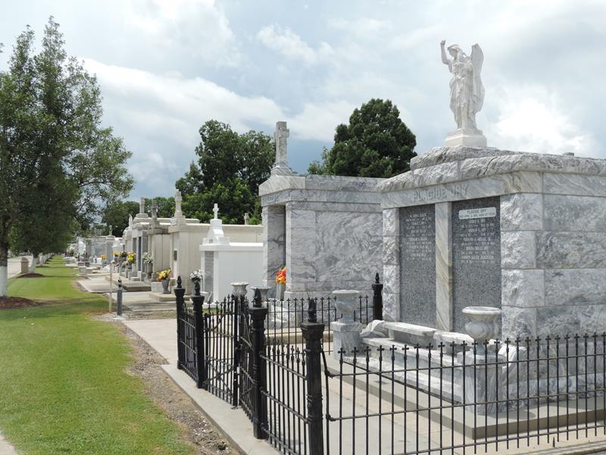

Mary Christy Vicknair Falcon, a longtime resident of LaPlace and current resident of Ponchatoula, passed away on Wednesday, February 7, 2024 at the age of 74.
Beloved wife of the late Owen Francis Falcon, Jr., for 50 years. Loving mother of Troy Falcon (Jennifer), Toby Falcon (Lisa) and Trey Falcon (Jessica). Grandmother of Emily Falcon, Sara Falcon, Andrew Falcon, Ethan Falcon, Riley Falcon, Bailey Falcon, Evan Falcon, Eli Falcon, Amelia Falcon and Michael Rodrigue, III. Daughter of the late Clinton Joseph Vicknair and Blanche Battard Jacob Vicknair. Sister of Lea Manno, Tamara LeBlanc, Jude Vicknair, Robin Vicknair, and the late OJ Jacob and Myrna Jacob. Also survived by numerous nieces and nephews.
Relatives and friends are invited to attend the Visitation and Memorial Service at St. Peter Catholic Church, 1550 Hwy 44, Reserve, LA on Friday, February 16, 2024. Visitation will be held at the church from 8:00 a.m. to 11:00 a.m. followed by a Memorial Mass at 11:00 a.m. Inurnment in St. Peter Cemetery, Reserve, LA.
In lieu of flowers, please consider a donation in her memory to the American Cancer Society, 2605 River Road, New Orleans, LA 7012

Millet-Guidry Funeral Home, LaPlace, Louisiana
February 9, 2024

