Ronald M. Falgoust

December 23, 1947 - July 8, 2024

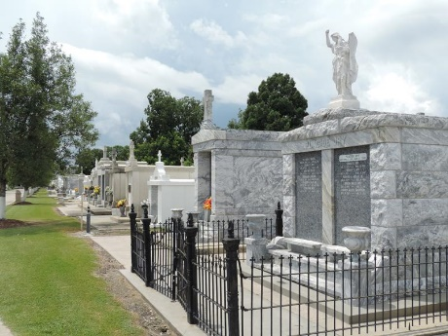

Ronald M. Falgoust passed away peacefully on July 6, 2024. He was a native of Reserve, Louisiana and resident of LaPlace, LA. He was born on December 23, 1947 to the late Elma Terrio Falgoust and John H. Falgoust, of Reserve, LA. He is survived by his sister, Sharon F. Cassagne (the late Ronnie), and Malcolm Falgoust (the late Debbie Lafitte) and his beloved canine friend, Prince. He is preceded in death by his brother and sisters, John H. Falgoust, Jr, Joyce F. Lafontaine (the late Max), and Mary Phillis Falgoust, and his nephews, Tyler Falgoust (Nancy) and Michael LaFontaine. He is survived by many nieces and nephews who will miss him dearly, many as he called “George” all in good fun.
He enjoyed his daily Waffle House trips for coffee and breakfast with Sharon and Malcolm. He was an avid LSU fan and especially enjoyed watching LSU Baseball and going over the daily game recap with family and friends. In his earlier years he served the United States Army and became a successful life insurance agent and licensed real estate agent.
The family would like to extend a great appreciation to the Ochsner Hospital organization for their kindness and commitment to him these past few weeks.
Relatives and friends are invited to attend the Visitation and Funeral Mass at St. Peter Catholic Church, 1550 Hwy 44, Reserve on Thursday, July 11, 2024. Visitation will be held at the church from 10:00 a.m. to 11:00 a.m. followed by a Funeral Mass at 11:00 a.m. Interment in St. Peter Cemetery, Reserve, LA.

Millet-Guidry Funeral Home, LaPlace, Louisiana
July 9, 2024

