Alpha L. Faucheux
July 1, 1921 – July 2, 2007

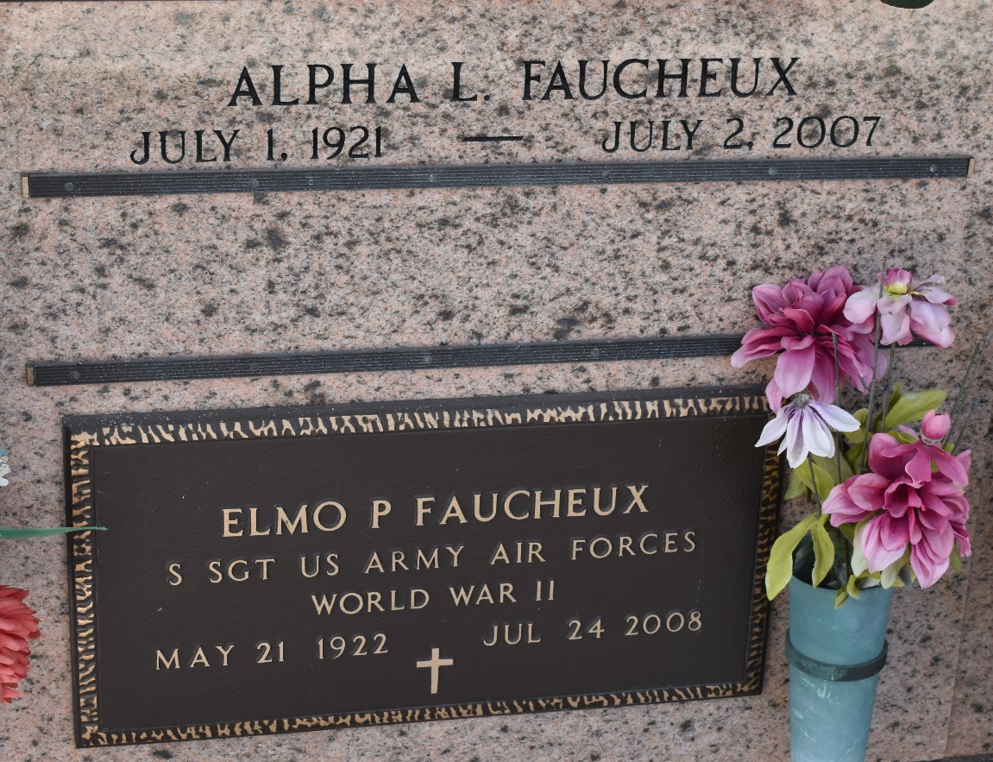

Alpha L. Faucheux, on Monday, July 2, 2007 at 1:30 p.m. Beloved wife of Elmo Faucheux for 61 years. Mother of Robert, Patricia, Cathryn and Mark Faucheux. Also survived by 6 grandchildren and 4 great grandchildren. Age 86. A native of St. Louis, MO. and a resident of Laplace for the past 60 years.
Relatives and friends of the family, also the St. Joan of Arc Thrift Shop and Ladies Altar Society are invited to attend services.
Visitation at Millet-Guidry Funeral Home, 2806 W. Airline Hwy, Laplace, on Thursday, July 5, 2007 from 8:30 am to 10 am. Followed by religious services at the funeral home chapel at 10 am. Burial in St. Peter Cemetery, Reserve.

Times-Picayune, The (New Orleans, Louisiana
4 July 2007

