Clifford Joseph Faucheux
November 1, 1927 – March 28, 2020

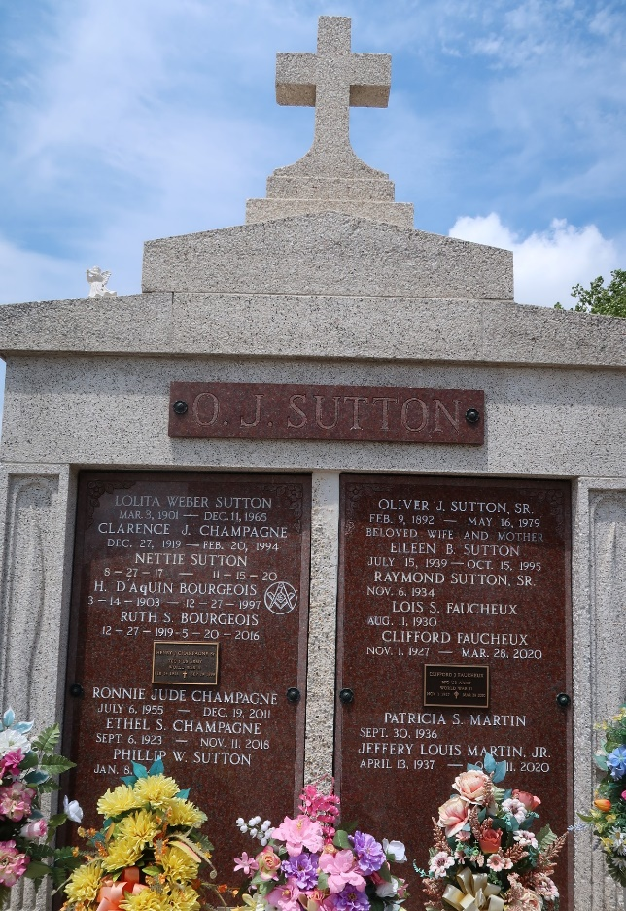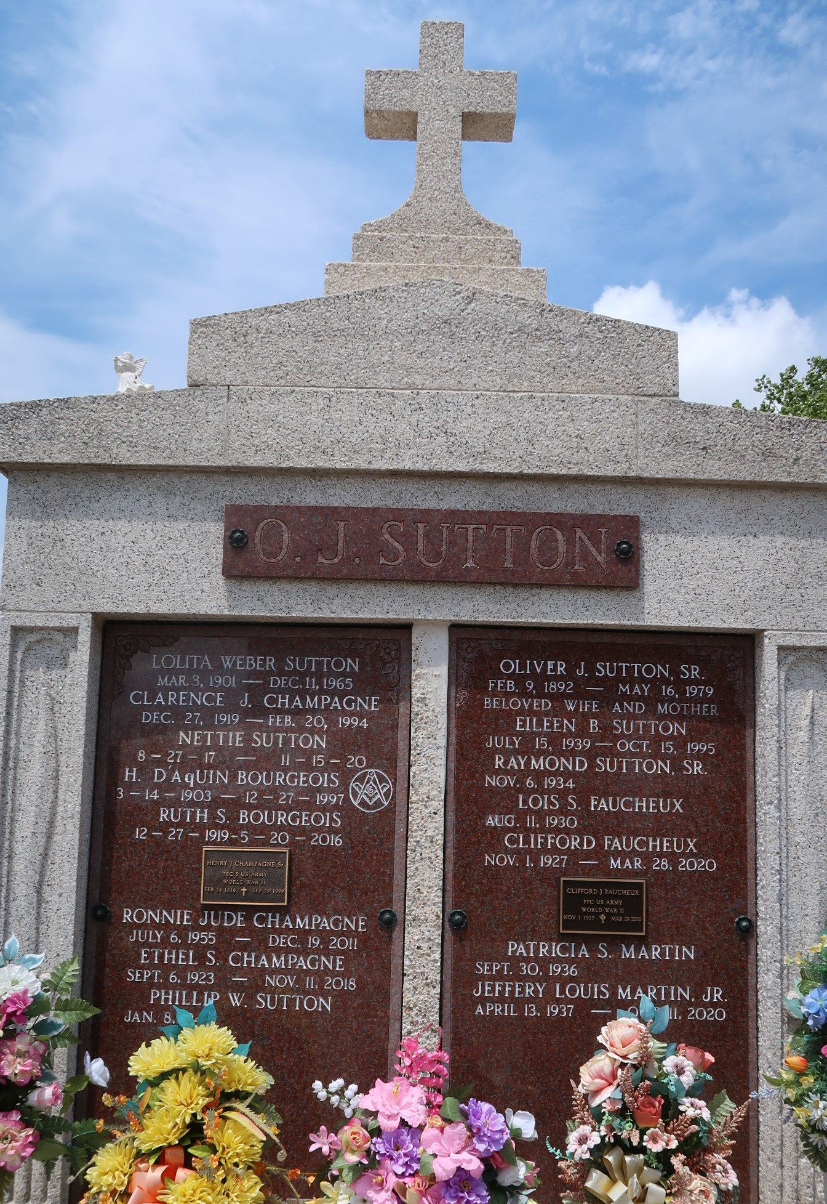

Clifford Joseph Faucheux, a resident of Reserve, was born on November 1, 1927 and passed away on Saturday, March 28, 2020 at the age of 92.
He is survived by his wife, Lois Sutton Faucheux, daughters, Lynne Gill and husband Roger, Yvonne Landry, Ellen Lambert and husband Maurice, Donna Lambert and husband Norman and Janis St. Amant and husband Kerry; 14 grandchildren, Roger, Brian, Steven, Johnathon, Lauren, Allison, Mark, Kelly, Lindsay, David, Todd, Joey, Scott, and Jordan; 30 great-grandchildren; and siblings, Cleve Faucheux, Emma Murry and Alice Vicknair.
He is preceded in death by his parents, Lionel and Louise Faucheux; son-in-law, Joey Poirrier Sr.; and siblings, Wilbert Mollere and Anna Heltz.
A private funeral service will be held for his immediate family.
Clifford was a loving husband, father, and grandfather. He will be greatly missed.

Rose Lynn Funeral Services, Lutcher, Louisiana

