Elmo Pierre Faucheux
May 21, 1922 – July 24, 2008

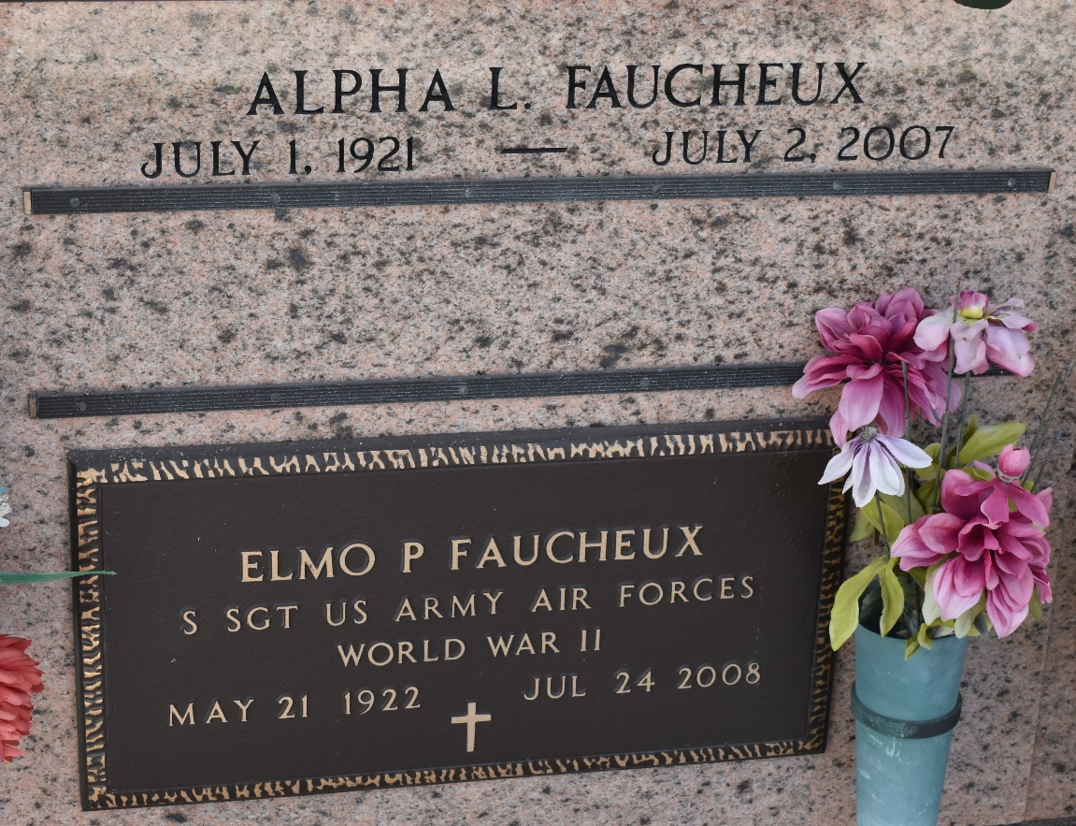

Elmo Pierre Faucheux on Thursday, July 24, 2008 at 7:00PM.
Beloved husband of the late Alpha Faucheux. Father of Robert, Patricia, Cathryn and Mark Faucheux. Also survived by 6 grandchildren and 4 great-grandchildren. Son of the late Robert and Estelle Millet Faucheux. Brother of Therese McTopy, the late Allen Faucheux and Rose Keller. Age 86 years. A native and resident of LaPlace, LA.
Relatives and friends are invited to attend services. Visitation at Millet-Guidry Funeral Home 2806 W. Airline Hwy. LaPlace, La. on Tuesday, July 29, 2008 from 8:30AM to 10:00AM. Followed by Religious Services at the Funeral Home Chapel at 10:00AM. Burial in St. Peter Cemetery, Reserve, LA.

Times-Picayune, The (New Orleans, Louisiana
26 July 2008

