James Eugene Felder

November 5, 1948 - May 4, 2024

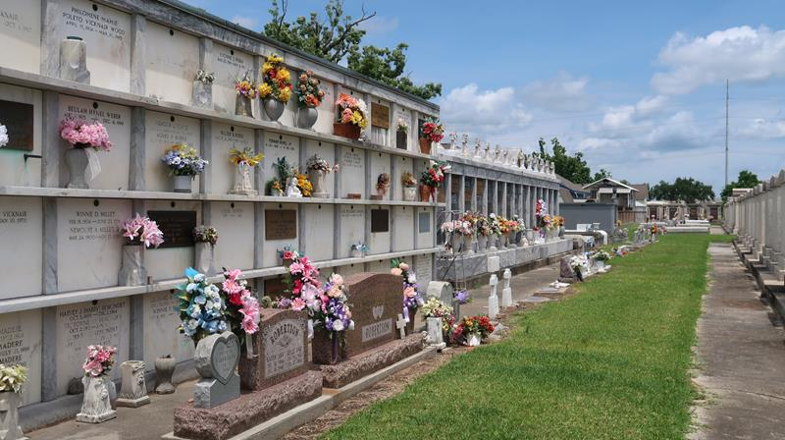

James Eugene Felder passed away on Saturday, May 4, 2024 at the age of 75. He was born in Washington, DC and a resident of LaPlace, LA.
Beloved husband of the late Joan DeLaneuville Felder. Loving father of Lauren Felder Sandefer. Grandfather of Lakin Felder and Tyler Sandefer. Great-grandfather of Ember Felder and Eden Tamplain. Son of the late Morris Leon Felder and Caryl Laraine Avery. Step-son of Maureen Felder. Brother of Daniel Felder (Karen), Michael Felder, Lois Felder Gordon, and Morris Felder, Jr. Also survived by nieces, nephews and cousins.
Relatives and Friends are invited to attend the Visitation and Funeral Mass at St. Joan of Arc Catholic Church, 529 W. 5th Street, LaPlace on Wednesday, May 15, 2024. Visitation will be held at the Church from 10:00 a.m. to 12:00 p.m. followed by a Funeral Mass at 12:00 p.m. Interment in St. Peter Cemetery.

Millet-Guidry Funeral Home, LaPlace, Louisiana
May 9, 2024

