Joan (Delaneuville) Felder

January 27, 1948 - February 22, 2024

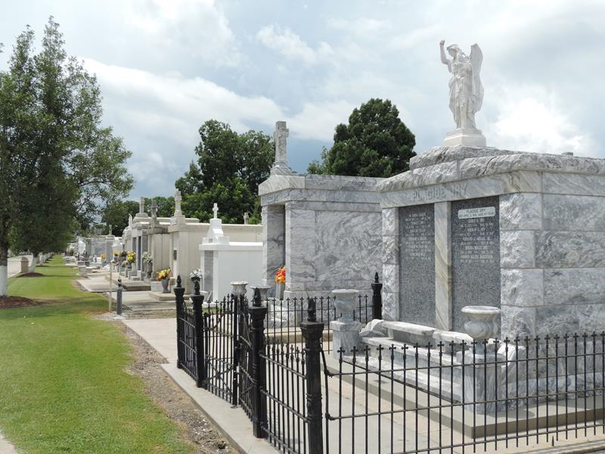

Joan Delaneuville Felder passed away on Thursday, February 22, 2024 at the age of 76. She was born in Reserve, LA and a resident of LaPlace, LA.
Beloved wife of James Eugene Felder for 56 years. Loving mother of Lauren Sandefer. Grandmother of Lakin Felder and Tyler Sandefer. Great grandmother of Ember Felder and Eden Tamplain. Daughter of the late Eugene Delaneuville and Ella Vicknair Delaneuville. Sister of the late Raymond Delaneuville, Eugene Delaneuville, Jr. and Robert Delaneuville. Also survived by numerous nieces, nephews, and cousins.
Joan graduated from Leon Godchaux High School in 1966 and then retired from the Drug Enforcement Agency after 33 years.
Relatives and friends are invited to attend the Visitation and Funeral Mass at St. Joan of Arc, 1550 Hwy. 44, LaPlace on Wednesday, February 28, 2024. Visitation will be held at the church from 10:00 a.m. to 12:00 p.m. followed by a Funeral Mass at 12:00 p.m. Interment in St. Peter Cemetery, Reserve, LA.

Millet-Guidry Funeral Home, LaPlace, Louisiana
February 27, 2024

