Delphine (St. Martin) Flynn
1927 – October 15, 2010

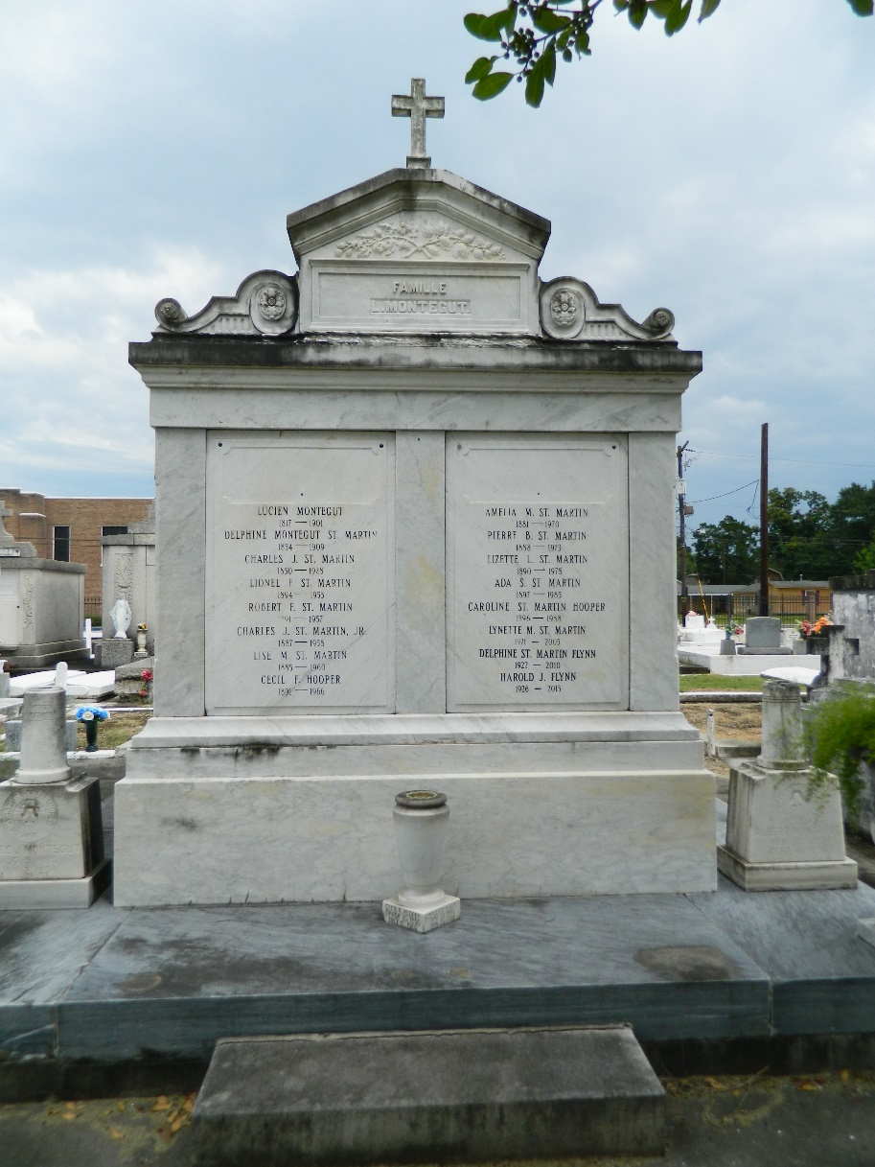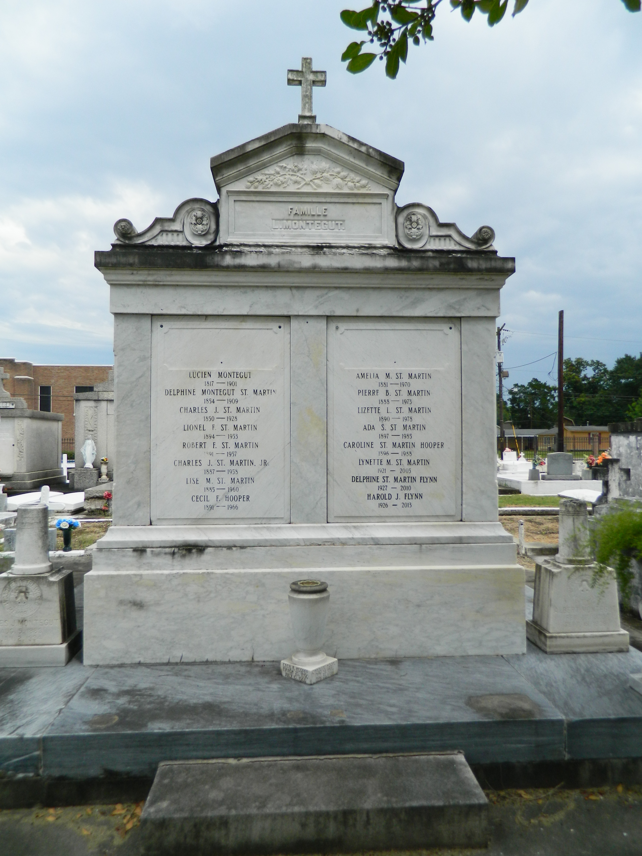

A native and resident of LaPlace, Delphine St. Martin Flynn died peacefully at her home Friday, Oct. 15, 2010. She is survived by her beloved husband, Harold J. Flynn; children, Peggy Bienvenu and husband Alden, Patti Clement and husband Kirt, Harold Flynn Jr. and wife Toni, Kathy Simino, Stephen and wife Donna, and Susan Flynn; grandchildren, Adele Tibler and husband John, Christopher and fiancée Leanne Pettit, Elizabeth Clement, Matthew, Ellen, Megan, Ryan and Sean Flynn; and great-grandsons, Bryce Cason and Aiden Tibler. She was the sister of Marie Richart, Gerard and Charles St. Martin. She was preceded in death by her parents, Peter B. and Lizette L. St. Martin; and siblings, Peter, Lynette and Roland St. Martin and Leah Soulier. Also survived by numerous nieces and nephews.
"Miss Delphine" was a parishioner of St. Joan of Arc Catholic Church in LaPlace and had an active role in their school thrift shop, St. Vincent de Paul and Ladies Altar societies. She was also a recipient of the Medal of The Order of St. Louis, Archdiocese of New Orleans.
Relatives and friends are invited to attend services. Visitation at Millet-Guidry Funeral Home, 2806 W. Airline Highway, LaPlace, Sunday, Oct. 17, from 5 p.m. to 8 p.m. Visitation resumes at the funeral home Monday from 11 a.m. to 12:45 p.m. A Mass will follow at St. Joan of Arc Catholic Church, LaPlace, at 1 p.m. Burial in St. Peter Cemetery, Reserve.

Advocate, The (Baton Rouge, Louisiana)
Sunday, October 17, 2010

