Harold J. Flynn Sr.
1926 – November 10, 2013

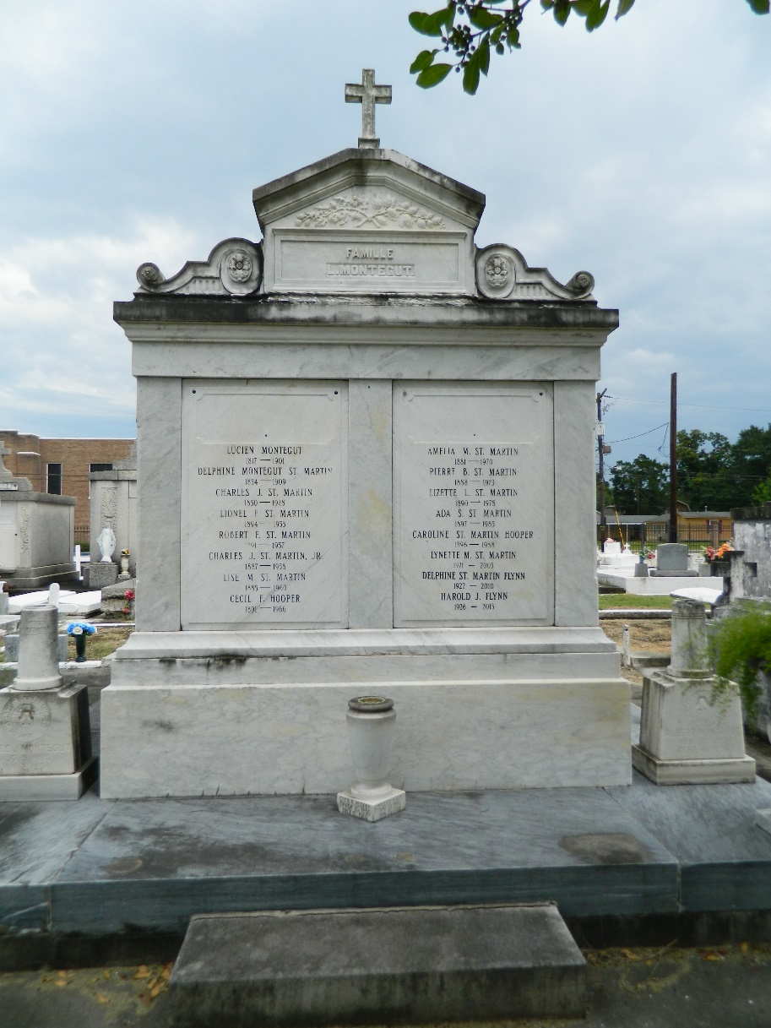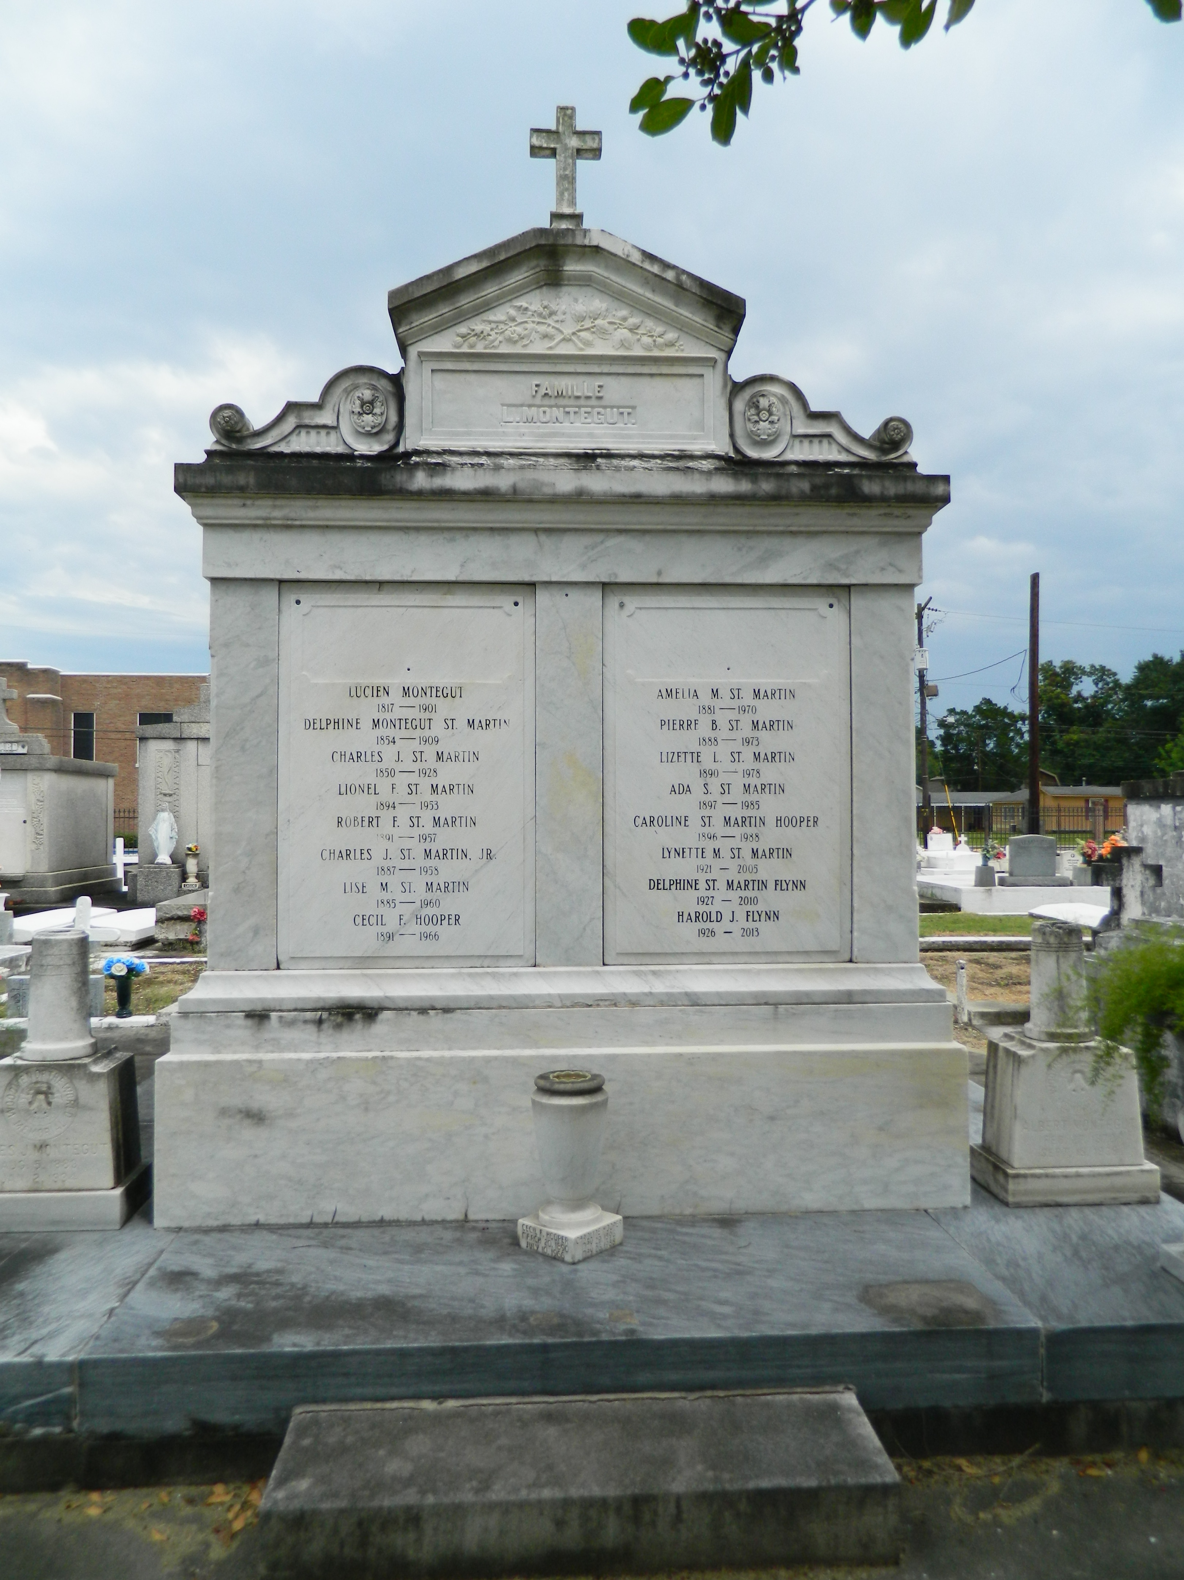

Harold J. Flynn, Sr., age 87, died at home on Sunday, November 10, 2013. He was the beloved husband of the late Delphine St. Martin Flynn. He is survived by his children: Peggy Bienvenu (Alden), Patti Clement (Kirt), Harold Flynn, Jr. (Toni), Kathy Simino, Stephen Flynn (Donna) and Susan Flynn; grandchildren: Adele Tiblier (John), Christopher Clement (Leanne), Elizabeth Clement, Matthew Flynn, Ellen Benedetto (Daniel), Ryan Flynn and fiancee Carly Trepagnier, Megan Flynn and Sean Flynn; great-grandsons Bryce Cason and Aiden Tiblier.
He retired as a project engineer from Shell Oil in Norco and was a civil engineer and professional land surveyor. Harold was an active member of both St. Joan of Arc Catholic Church and School. He was also involved in the Lions Club and served as President; he was the first Grand Knight of the Msgr. Dennis Bergeron Knights of Columbus; an original member of Riverlands Country Club; American Legion; and The Fore!Kids Foundation. He was an Eagle Scout and a Scoutmaster of the local Boy Scout Troop. He was also a recipient of the Medal of the Order of St. Louis, Archdiocese of New Orleans.
Relatives and friends are invited to attend services. Visitation at St. Joan of Arc Catholic Church, 529 W. 5th St., LaPlace, LA on Thursday, November 14, 2013 from 6:30 p.m. to 8:30 p.m. and on Friday from 9:30 a.m. followed by Mass at 11:30 a.m. Burial in St. Peter Cemetery, Reserve, LA. Arrangements by Millet-Guidry Funeral Home, LaPlace, LA.

Advocate, The (Baton Rouge, Louisiana)
Monday, November 11, 2013

