Susette Guidry Forsythe
January 22, 1947 - January 5, 2024

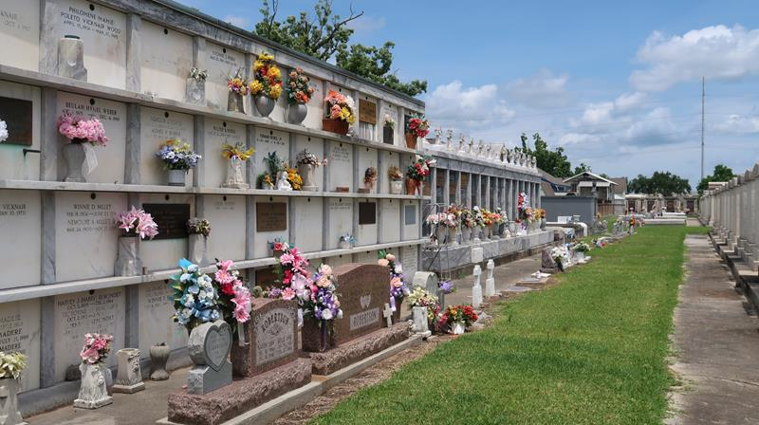

Susette Guidry Forsythe passed away on Friday, January 5, 2024 at the age of 76. She was born in New Orleans, LA and was a resident of Reserve, LA.
Beloved mother of Michael Forsythe, Yancy Forsythe (Lisa), Nicole Young (Warren) and Brett Forsythe (Monica). Daughter of the late Vera Jacob Clement (the late, Alden) and Julian “Cocoon” Guidry. Sister of Julian M. Guidry, Jr., Sue C. Bertrand, Deborah G. Borne, Alden Clement, Jr. and the late Marie Celeste Louviere and Maurice “Boomba” Guidry. Also survived by 15 grandchildren, 4 great-grandchildren and many nieces and nephews.
Relatives and friends are invited to attend the Visitation and Funeral Service at Rose Lynn Funeral Home, 1870 Cabanose Ave., Lutcher, LA on Friday, January 12, 2024. Visitation from 9:00 a.m. to 11:00 a.m. followed by a Funeral Service at 11:00 a.m. Interment in St. Peter Cemetery, Reserve, LA.
Rose Lynn Funeral Home, Lutcher, Louisiana
January 10, 2024

