Carol (DeLaneuville) Frederiksen
February 25, 1937 – July 11, 2020

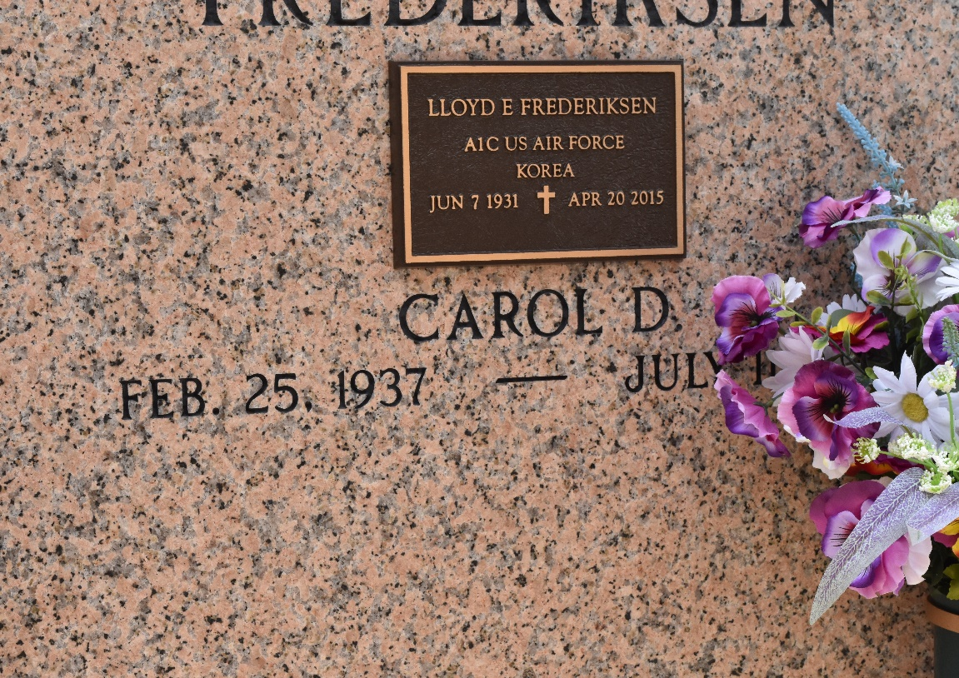

Carol D. Frederiksen passed away on July 11, 2020. She was born on February 25, 1937 and lived all of her life in Reserve, Louisiana. She was a graduate of Leon Godchaux High School class of 1954. She married Lloyd E. Frederiksen of Racine, Wisconsin on July 28, 1956. She loved spending time with family and friends.
She is survived by her children: Michael Frederiksen, Linda Frederiksen Hymel (Jerry), Kathy Frederiksen Brookins (Don) and Karen Frederiksen Heltz (Donald) and sister: Joy D. Migliore (Don). Carol is the proud grandmother of 10 grandsons and 9 great-grandchildren.
She is preceded in death by her husband, Lloyd E. Frederiksen; her parents Henry Clay and Pauline Delhommer DeLaneuville and her twin brother Harold DeLaneuville.
Visitation will be held at St. Peter Catholic Church in Reserve, LA on Wednesday, July 15, 2020 from 10:00 am until the funeral time. A Mass of Christian Burial will take place at 11:00 a.m. at the church. Interment will follow in the church cemetery.

Rose Lynn Funeral Home, Lutcher, Louisiana

