Michael John Frederiksen, Sr.
March 11, 1960 - November 24, 2024
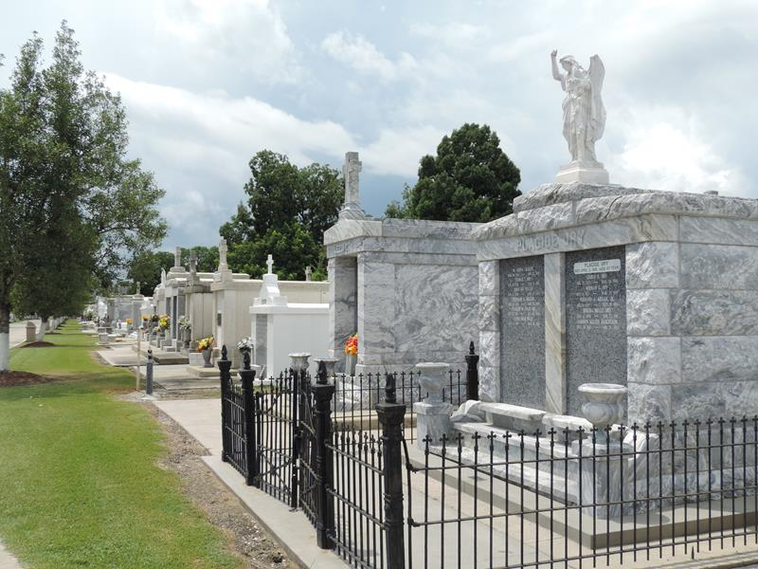

Michael John Frederiksen, Sr. passed away on November 24, 2024.
Beloved son of the late Lloyd and Carol Frederiksen. Michael is survived by Michael (Liz), Robby, Adam, Chance (Chanie), Gabriel and Jason (Ashley); 3 granddaughters, Nylah, London, and Sophie; and 1 grandson soon to be born, Hudson. He is also survived by his sisters, Linda (Jerry), Karen (Donald), and Kathy (Don).
A Graveside Service will be held at St. Peter Cemetery in Reserve, LA on Friday, December 6, 2024 at 11:00 a.m.

Rose Lynn Funeral Home, Lutcher, Louisiana
November 26, 2024

