Bernice (Mury) Fremin-Louviere

October 2, 1929 – February 2, 2023

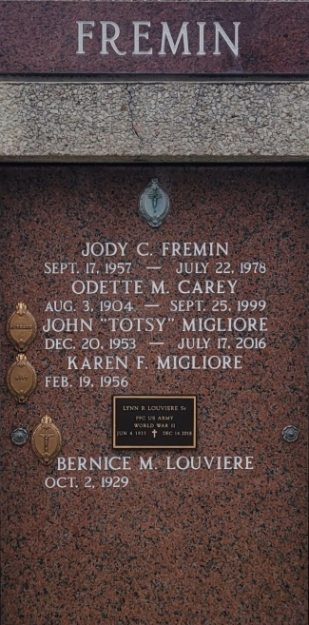

Bernice Mury Louviere, 93 years old, died at home in Montz, Louisiana on February 2, 2023, surrounded by family.  
 Bernice was one of eight children. Her parents are Julin Mury and Lucia Mury . Born to them on October 2, 1929.  
 Bernice is preceded in death by her husband, Tony Louviere; brothers, Victor and Andrew Mury; sisters, Eunice Brandt, Daisy Meyer, Elsie Youman, Ruth Casler, Elma Champagne; daughter, Jody Catherine Fremin; son-in-law, John (Totsy) Migliore; her first husband and father of her three children Alvin Fremin.  
 She is survived by her children Keith Fremin and Karen Migliore; sister-in-law- Emma Mury; grandsons, Jarrod Fremin, Keith Fremin, Evan Fremin, and John Migliore; granddaughters, Leslie Anderson, Jade Fayard (Chris Fayard); great-grandchildren, Abby, Jolene, Hunter, Brett, Conner, Chelsea, Elana, Jordan, Adalynn, Dominic, Rome; great great grandchild Mila; and many cousins, nieces, and nephews.  
 Bernice was a loving and dedicated mother and grandmother. She enjoyed getting her family together, cooking, sewing, decorating, and keeping up with her yard.  
 Relatives and friends are invited to the Visitation and Funeral Service on Saturday, February 11, 2023, at Millet-Guidry Funeral Home, 2806 West Airline Highway, LaPlace, LA. Visitation from 9:00 a.m. till 11:00 a.m. with a Funeral Mass at 11:00 a.m. Interment will immediately follow the Mass at St. Peter Cemetery in Reserve.

Millet-Guidry Funeral Home, LaPlace, Louisiana

February 7, 2023