Albert Joseph French Jr.
January 1, 1934 – May 28, 2018

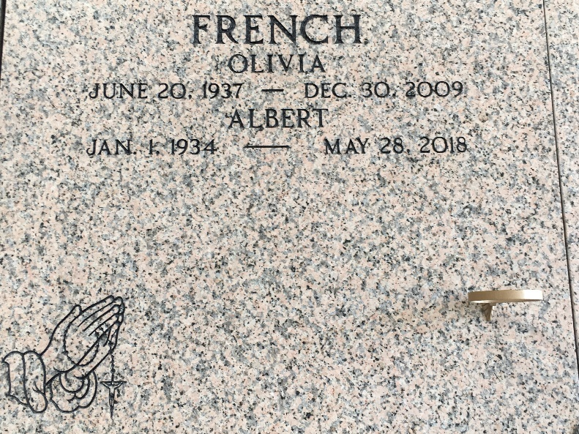
Photo by Team T-Lo

Albert Joseph “Bumpsy” French, Jr. was born on January 1, 1934 to the late Albert J. French Sr. and the late Rebecca Ruffin French in New Orleans, LA. He was reared by his Father and his step-mother the late Claudia Samuel-French along with his two brothers. He attended St. Joan of Arc Elementary School in New Orleans, LA. He earned his High School Equivalent in 1983 from East. St. John High School. Albert met and married Olivia Porche French and to this union were born three children: Suzanne, Evelyn and Alanna, joining their sister, Anita Keys Pierre.
In 1964 he moved to LaPlace, LA and started working at Robertson Tank Line while continuing his true passion part time in the home construction business. He retired in 1983, to start a new career as a Correctional Officer with St. John Parish Sheriff’s Office. During his time with the sheriff's office he served in many capacities including prison transportation. In 2001, he retired from the Sheriff’s office to begin yet another career as a security officer at Treasure Chest Casino. He left that role in 2003 to return to the Sheriff's office until full retirement in June 2005. Finally, in 2005, he was fully retired and enjoying his horses and life.
On Monday, May 28, 2018 at his home, the Angel of the Lord came and claimed his soul. He leaves to cherish his memory, his children; Suzanne French-Pruitt (Anthony) of Mountain House, CA, Evelyn French and Alanna French of Laplace, LA, one brother, George N. French of New Orleans, LA.; nine grandchildren; Grant Pierre, Jr., Lance French(Lakeria), Ashton Pierre (Stacey), Alonzo Patterson (Keimira), Alvin Zeringue III and Kevaughn Marshall(Delissa) all of Laplace, LA. Mark Pierre(Phyllicia) of Kenosha, WI, SGT Donavon Pierre(Nadine)U. S. Army, stationed in Ft. Polk, LA and Jeremy Pierre(Mia) U.S. Army stationed in Everett, WA,; twenty-two great grandchildren, Kyron Pierre, Drake Piere, Kaia Pierre, Ja’Kera Jarrow, Aniya French, Camerion Pierre, Braniya Pierre, Aaleya French, Alonzo Patterson, Jr., Ashton Pierre, Jr, Amyra Patterson, Romero Pierre, Skye Marshall, Lance French Jr, Mya Pierre, Chance French, Kevaughn Marshall, Jr, Ja’Koby Patterson, Aiden Pierre, Carter Pierre, Peyton Pierre and Brayden Marshall. One Godson, Donald Haynes, Jr. and a host of nieces, nephews, cousins and friends.
He was preceded in death by his parents, Albert French Sr and Rebecca R. French, his stepmother Claudia French, his wife, Olivia Porche French , his step daughter Anita Keys Pierre, one brother, Robert French Sr, one nephew George French, Jr. and one adopted son, Edwin Duhe, Jr. Relatives and friends of the family are invited to attend a Mass of Christian burial on Monday June 4, 2018 for 10:00am from Our Lady of Grace Catholic Church, 772- La 44 Reserve, La. Father Christopher Amadi Celebrant. Visitation at the church at 8:15 am, recitation of the rosary at 9:15 am. Entombment St. Peter Catholic Church Mausoleum Reserve, La.

Treasures of Life Funeral Services, Gramercy, Louisiana
October 7, 2018

