Olivia (Porche) French
June 20, 1937 – December 30, 2009

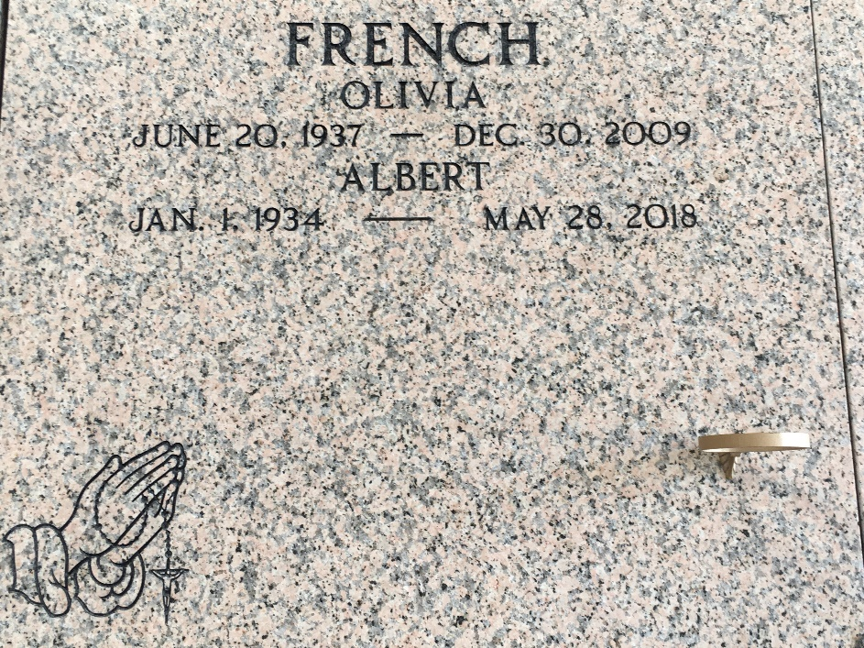
Photo by Team T-Lo

Olivia Porche' French, born June 20, 1937, the second of five children born to the late Morris and Evelyn Porche Sr. in Darrow, La. Olivia graduated from McDonough 35, attended Dillard University, earned a B.S. in Social Work and a Masters + 30 from Southeastern La. University.
In 1964 she met and married Albert French, Jr. To this union were born 3 children, Suzanne, Evelyn and Alanna who joined Anita, who was reared by Albert French. On Tues., Dec. 30, 2009 at River Parish Hospital she departed this life.
She leaves to cherish her memory her husband Albert French, Jr.; 4 daughters, 1 adopted son, 2 sisters, 1 brother, 9 grandchildren, 1 adopted grandson, 8 great grandchildren, a host of nieces, nephews, cousins and friends.
Preceded in death by her parents, a son Sterling Keys Jr., 2 brothers Melvin and David Porche'.
A Mass of Christian Burial will be held on Wed., Jan. 6, 2010 at Our Lady of Grace Catholic Church, 744 Hwy. 44, Reserve, La., at 11:00am. Visitation at the church after 9:00am. Recitation of the rosary at 10:00am. Entombment St. Peter Catholic Church Mausoleum, Reserve, La. Visitation on Tues. Jan. 5, 2010 from the funeral home 5-7pm. The Baloney Funeral Home LLC 399 Earl Baloney Dr., Garyville, La. 985-535-2540 In Charge of Arrangements.

The Times-Picayune, New Orleans
Jan. 5, 2010

