Clarence Adrian Frost
June 10, 1925 – January 25, 2005

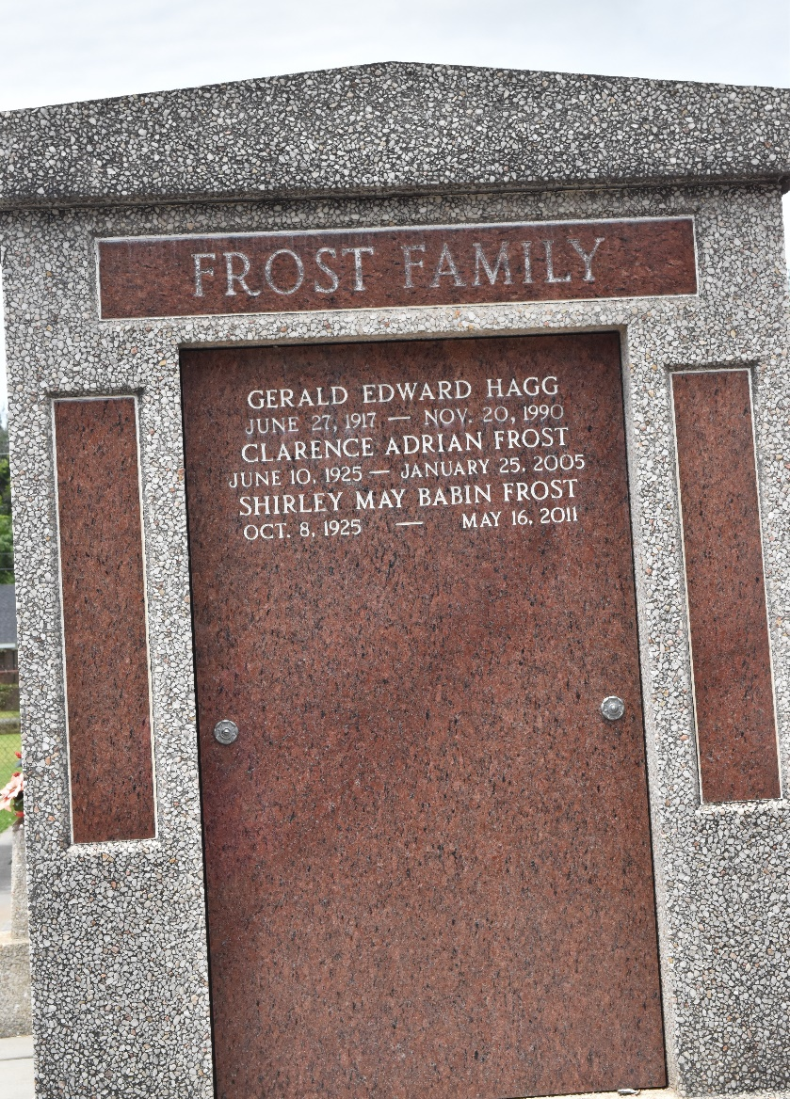

He died Tuesday, Jan. 25, 2005, at 7:37 a.m. He was the beloved husband of Shirley Babin Frost; father and father-in-law of Gregory D. and Lisa J. Frost, Emily Canzoneri, Adrienne and Curtis Stanley and Timothy J. and Cheryl G. Frost; and is also survived by eight grandchildren.
He was the son of the late Clayton and Emily Frost. He was 79, a native of Livingston and a resident of LaPlace for the past 50 years.
Relatives and friends of the family are invited to attend services. Visitation at Millet-Guidry Funeral Home, 2806 W. Airline Highway, LaPlace, on Friday, Jan. 28, from 9 a.m. until religious service in the chapel at 11 a.m. Burial in St. Peter Cemetery, Reserve. In lieu of flowers, memorial donations to the American Cancer Society preferred.

The Advocate, Baton Rouge, Louisiana
Jan. 26, 2005

