Shirley May (Babin) Frost
October 8, 1925 – May 16, 2011

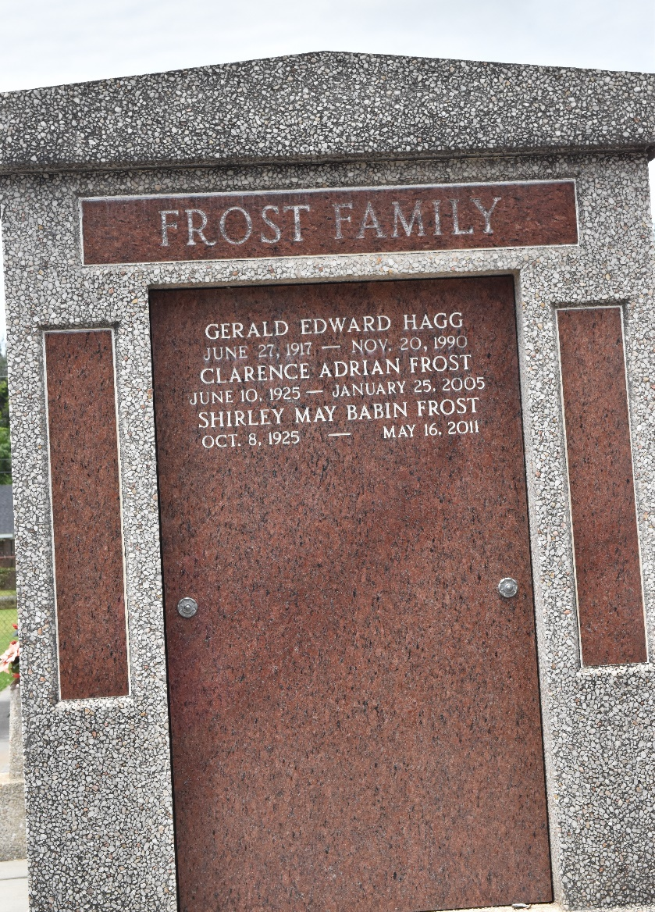

Shirley May Babin Frost passed away at home on Monday, May 16, 2011 at the age of 85. A lifetime resident of LaPlace, Louisiana, she was mother of four children: Gregory David Frost, married to Lisa Johnson Frost, Emily Elizabeth Frost Canzoneri, Adrienne Celeste Frost Stanley, married to Curtis Michael Stanley, and Timothy Julius Frost, married to Cheryl Guzzardo Frost.
She was a loving grandmother to her eight grandchildren: Bryan John Canzoneri, married to Justina Hijar Canzoneri, Emma Frost Burke, married to William Webster Burke, IV, Evan Peter Canzoneri, Elizabeth Adrienne Frost, Peter Julius Frost, Garrett Frost Stanley, Mason Grant Stanley, and Katherine "Katie" Emily Frost. She was a great-grandmother to two grandsons: Preston John Canzoneri and Peyton Reid Canzoneri. She is survived by her sister Myrtle Ann Babin Babcock and a number of nieces and nephews.
She was preceded in death by her loving husband of 53 years, Clarence Adrian Frost, by her parents Julius Alphonse Babin and Emma Bohn Babin, and her siblings Margery Babin Wylie and Robert Lewis Babin.
Relatives and friends of the family are welcome to attend the Funeral Services at Millet Guidry Funeral Home, 2806 W. Airline Highway, LaPlace on Wednesday, May 18, 2011 at 11 am, with visitation at 930 am. Interment will be at St. Peters Cemetery in Reserve, Louisiana.
In lieu of flowers, the family requests donations to the Alzheimer's Association - www.alz.org.

The Times-Picayune, New Orleans, Louisiana
May 17, 2011

