Francis C. Fulton
July 18, 1906 – June 23, 2000

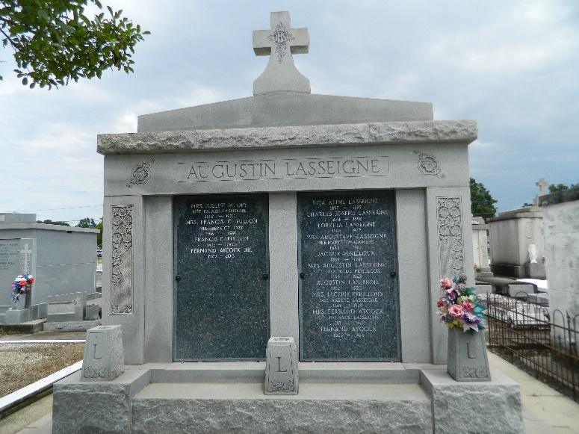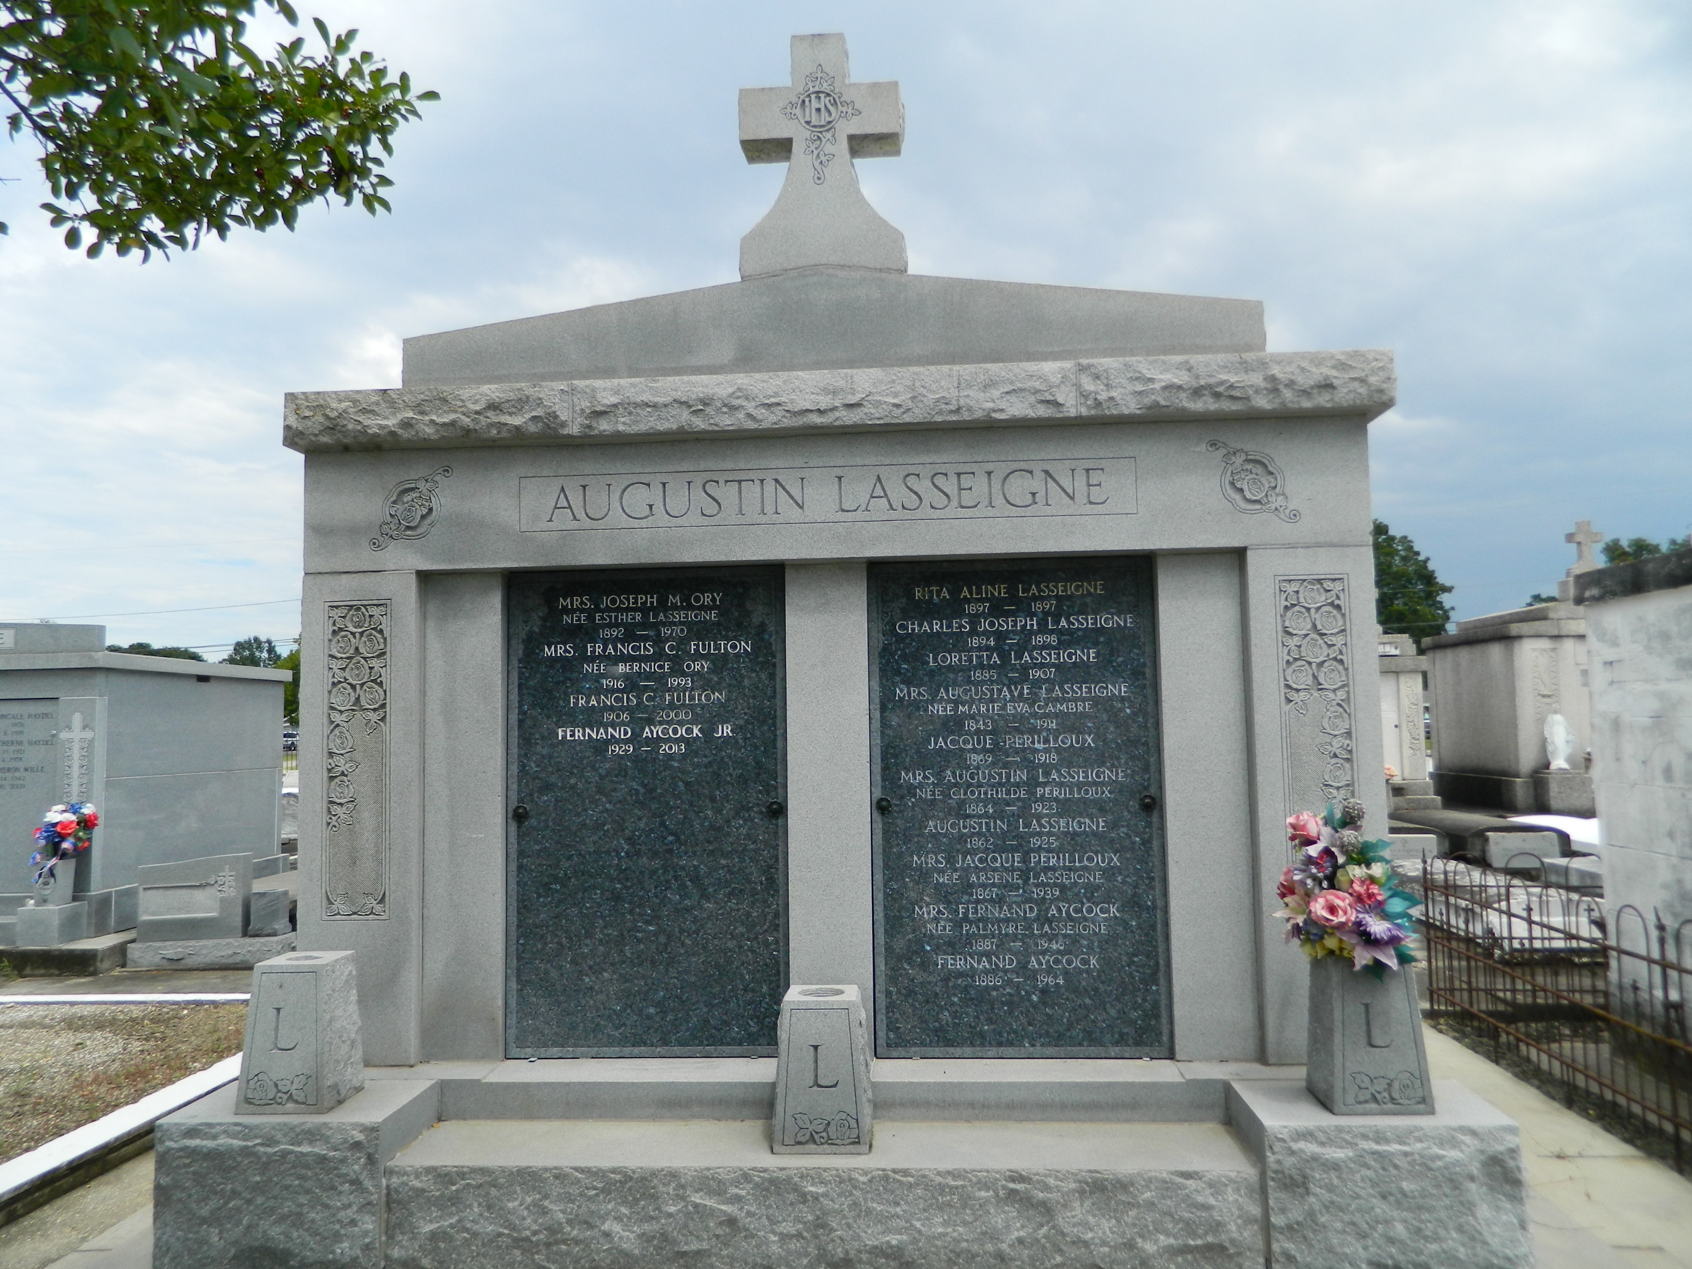

Francis "Fanny" Fulton, 93, a native of Mississippi and a resident of St. John Parish for 75 years, died June 23.
He was the husband of the late Bernice Ory Fulton and father of Melanie Ulmer, Anne Boucvalt, Angela Castay and Robert and Cogan Fulton. He is also survived by 15 grandchildren and five great-grandchildren.
Services were June 26 in the St. Joan of Arc Catholic Church, LaPlace, with interment at St. Peter Cemetery, Reserve.
L'Observateur, La Place, Louisiana
Tuesday, June 27, 2000

