Albert Gray, Sr.
November 19, 1927 – July 11, 2005

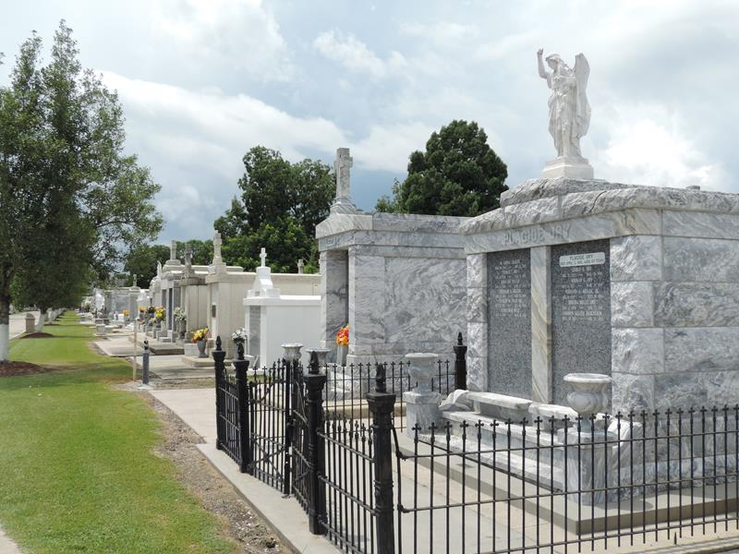
Photo by Team T-Lo

Albert (Koyo) Gray, Sr., departed this life on Monday, July 11, 2005 at his residence in LaPlace, LA.
Son of the late Clement and Jennie Gray. Husband of Sonja Gray. Father of Albert Jr., Romona, Elvera and Domingo Gray and the late Daryl Gray. Brother of Erlean Gray. Also survived by 10 grandchildren, 10 great-grandchildren, 1 daughter-in-law, Mercinia Gray; a host of nieces, nephews, cousins, other relatives and friends. A native of St. James, LA and a resident of LaPlace, LA. Age 77 years.
Priest and parishioners of Our Lady of Grace Catholic Church and all neighboring churches are invited to attend the Funeral Service on Thursday, July 14, 2005 at 11:00 a.m., 772 Hwy. 44 (River Road), Reserve, LA. Father Joseph Rodney - officiating. Interment in St. Peter Catholic Cemetery, Reserve, LA. Visitation on Thursday, July 14 from 9:00 a.m. until service time.
Service entrusted to HOBSON BROWN FUNERAL HOME Garyville, LA.
The Times Picayune, New Orleans, Louisiana
July 13, 2005

