Danielle Marie Gagnier
January 2, 1974 – February 1995

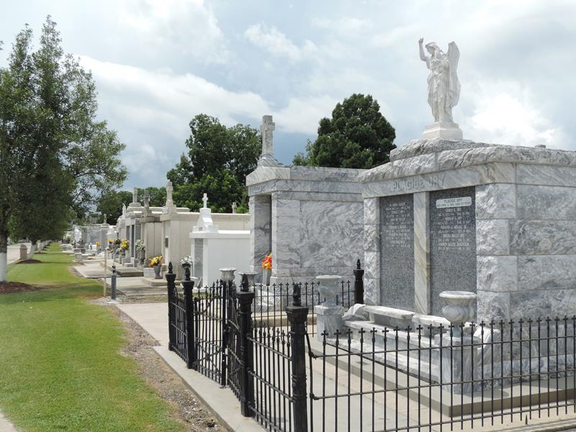

Danielle M. Gagnier, A Member Of The U.S. Marine Corps, Died Wednesday In A Motor Vehicle Accident In California. She Was 21. Mrs. Gagnier Was Born In Englewood, Calif., And Lived In Laplace For Two Years. She Attended Southern University In Baton Rouge. She Was A Private First Class
In The Marine Corps.
Survivors Include Her Husband, Rodney M. Warner; Her Parents, Dwight And Christine Gagnier; Her Stepmother, Denise Gagnier; And Grandparents Victoria Alexander, Louis Gagnier Sr. And Joyce Jones.
A Mass Will Be Said Tuesday At 10 A.M. At Our Lady Of Grace Catholic Church, 2950 Jefferson Highway In Reserve. Burial Will Be In St. Peter Cemetery. Robottom Mortuary Is In Charge Of Arrangements.

Times Picayune, New Orleans, Louisiana
February 6, 1995
**

California, U.S., Death Index, 1940-1997

Name Danielle Marie Gagnier
Social Security # xxx
Gender Female
Birth Date 2 Jan 1974
Birth Place California
Death Date 1 Feb 1995
Death Place San Diego
Mother's Maiden Name Alexander

