Charles R. Galatas
April 13. 1932 – May 31, 2019

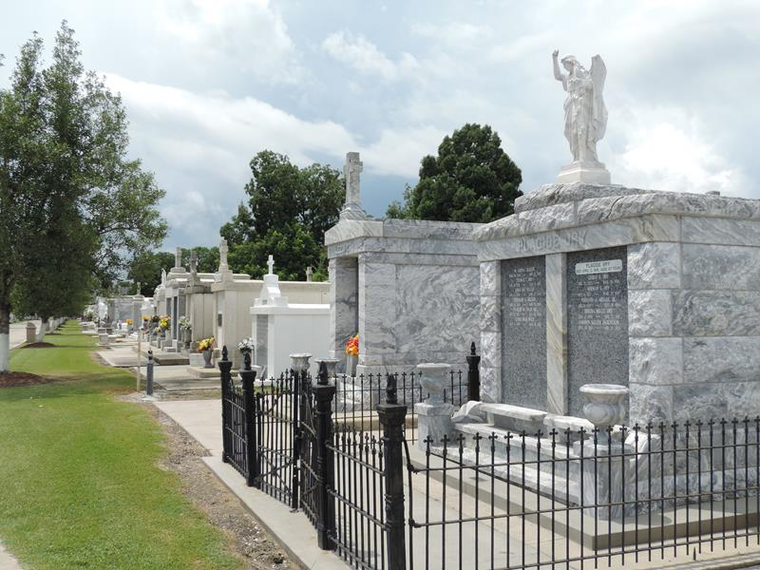

Charles R. Galatas passed away peacefully at his home at the age of 87 surrounded by his loved ones on May 31, 2019.
He was born in Garyville, LA and resided in Reserve, LA. Charles served in the US Army during the Korean War, stationed in Germany. He enjoyed hunting and fishing. He was a family man; he loved his wife, children, grandchildren, and great-grandchildren very much.
He is survived by his wife of 64 years, Roseanna Landry Galatas; sons, Charles "Bobby" Galatas (Denise), Curtis Galatas (Tonia), and Raymond Galatas; sisters, Anna Torres and Joyce Leboeuf (Russell); 10 grandchildren and 8 great-grandchildren. He was preceded in death by his parents, Theodore Sr. and Espasie Galatas; brothers, Theodore Jr. "T.J." Galatas and William "Skeet" Galatas; sister, Hazel Galatas Melancon; daughter-in-law, Wendy Vicknair Galatas; and granddaughter, Jessica Galatas.
The family would like to thank Dr. Colin Bailey and Egan Home Health & Hospice.
Visitation will be held on Monday, June 3, 2019 from 9 am until a Mass of Christian Burial at 11 am at St. Peter Catholic Church in Reserve, LA. Burial to follow in the St. Peter's Cemetery. Rose Lynn Funeral Services is in charge of the arrangements.

The New Orleans (LA) Advocate
Jun. 1 to Jun. 3, 2019

