William Clifton Galatas Jr.
December 31, 1944 – October 8, 1984

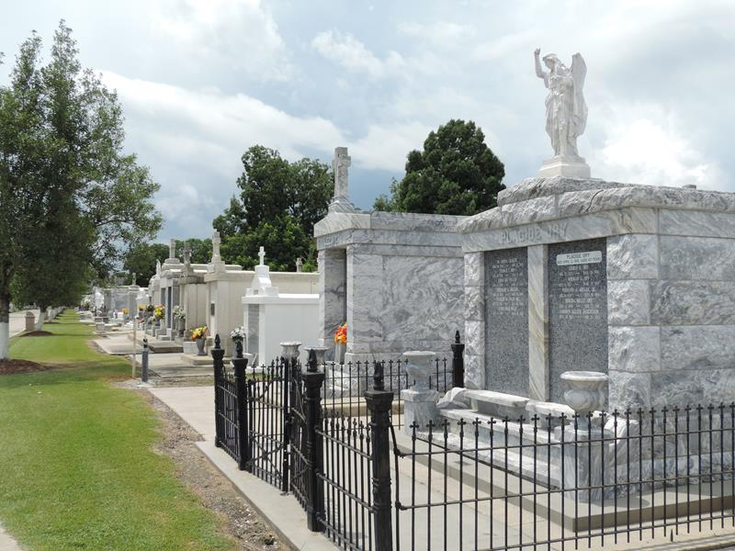

William (Little Skeet) Galatas Jr died Monday 8 Oct 1984 at 3:30 p.m. at age 39 years. He was the husband of Barbara Duhe Galatas and the son of Billie Bourgeois Andre of New Roads, Louisiana, and the late William Galatas Sr.
He was the father of Scott and Rachel Galatas and the brother of Roussell Galatas of St Rose, Louisiana, Newton Galatas of Baton Rouge, Louisiana, and the late Earline Hammatt. He was the half-brother of Gynelle Stoker, Charlie Galatas, both of St Rose and step-brother of Loretta Frommeyer of St Rose. Also survived by a host of nieces and nephews. He as a native and lifelong resident of Garyville, Louisiana.
Services from Millet Funeral Home, Reserve, Louisiana, on Wednesday 10 Oct 1984 followed by religious services at St Hubert Catholic Church, Garyville. Interment in St Peter Cemetery, Reserve.
The Times-Picayune, New Orleans, Louisiana
9 Oct 1984

