Kathern (Collins) Galatas

October 24, 1960 – October 11, 2016

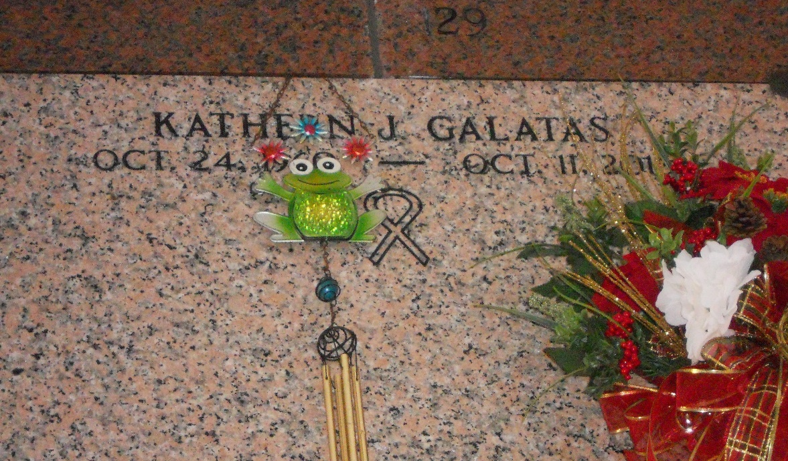

Photo by Team T-Lo

Kathern Collins Galatas passed away on Tuesday, October 11, 2016 at the age of 55 at her Garyville residence. She was a native of New Orleans and a Garyville resident for the past 37 years.

Loving wife of Barry J. Galatas. Daughter of Virginia "Sue" Collins and the late Gerome F. Collins, Sr. Sister of Carolyn Sue Fabre, Gerome F. Collins, Jr., Charlotte Collins Allnet and Theresa Ann Lacy. She is also survived by a host of nieces and nephews.

Relatives and friends are invited to attend the visitation at Millet-Guidry Funeral Home, 2806 W. Airline Hwy., LaPlace on Thursday, October 13, 2016 from 6:00 p.m. until 9:00 p.m. and on Friday, October 14, 2016 from 9:00 a.m. until 11:00 a.m. with funeral services at 11:00 am in the Funeral Home Chapel. Interment will follow in St. Peter Cemetery.

In lieu of flowers donations are requested to offset funeral expenses.

Millet-Guidry Funeral Home, LaPlace, Louisiana