Raymond R. Galatas
December 11, 1959 – April 11, 2024

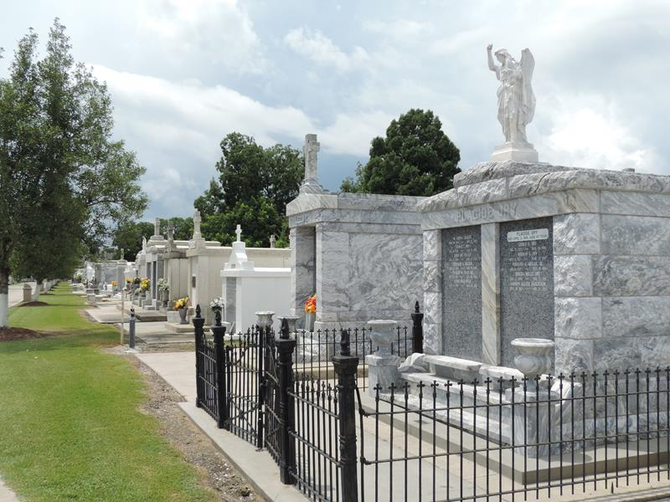

Raymond R. Galatas passed away on Thursday, April 11, 2024 at the age of 64.
He was born on December 11, 1959 to Roseanna Landry Galatas and the late Charles Galatas. Raymond was married to the late Wendy V. Galatas for 30 years. Anyone that knew him knew his love for fishing, hunting and cooking for his family.
He is survived by his second wife Cynthia Savoie Galatas; daughters, Katti Lee (Zack) and Vicki Mason (Phillip); granddaughters, Harper Rose Lee and Sophia Mason; mother, Roseanna Landry Galatas; and brothers, Charles “Bobby” Galatas (Denise) and Curtis Galatas (Tonia); and many nieces and nephews and his fishing family.
Relatives and friends are invited to attend the Visitation and Funeral Mass at St. Peter Catholic Church, 1550 Hwy 44, Reserve on Tuesday, April 16, 2024. Visitation will be held at the church from 9:00 a.m. to 11:00 a.m. followed by a Funeral Mass at 11:00 a.m. Interment in St. Peter Cemetery, Reserve, LA.

Rose Lynn Funeral Home, Lutcher, Louisiana
April 12, 2024

