Rose Marie (Duhe) Galatas
October 1, 1925 – February 28, 2006

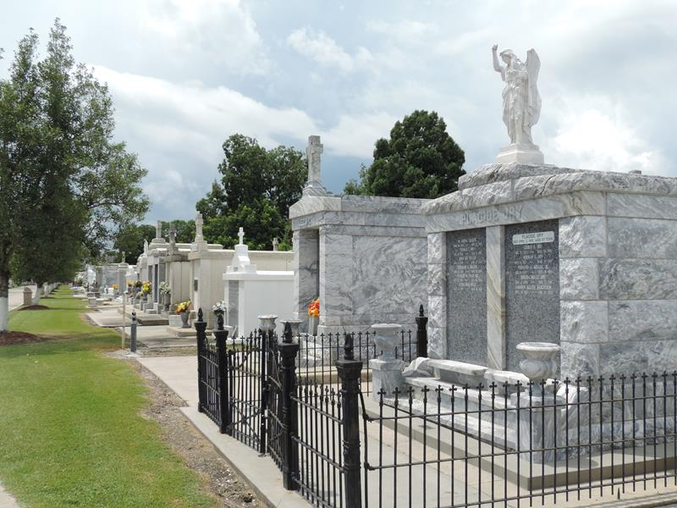
Photo by Team T-Lo

Rose Duhe Galatas on Tuesday, February 28, 2006 at 5:15 a.m.
Beloved wife of the late T.J. (Buddy) Galatas. Mother and mother-in-law of Karen G. and Lanny Cambre of Garyville, LA, Catherine G. and Gerald Templet of St. Amant, LA and Barry and Kathy Galatas of Garyville, LA. Daughter of the late Paul and Louise Millet Duhe. Sister of the late Eunice Tassin, Cecile Cooper, Early, Murphy, Lester, Leroy and Harris Duhe. Also survived by 7 grandchildren and 7 great-grandchildren. Age 80 years. A native of Reserve, LA and a resident of Garyville, LA for the past 56 years.
Relatives and friends of the family; also The Ladies Auxiliary 8167 and Ladies Altar Society are invited to attend services. Visitation at St. Hubert Catholic Church, Garyville, LA on Thursday, March 2, 2006 from 9:00 a.m. until 12:00 noon. Followed by Religious Services at the Church at 12:00 noon. Burial in St. Peter Cemetery, Reserve, LA. Arrangements by MILLET-GUIDRY FUNERAL HOME, LaPlace, La.

The Times-Picayune, New Orleans, Louisiana
Mar. 1, 2006

