Wendy (Vicknair) Galatas
November 18, 1955 – February 9, 2019

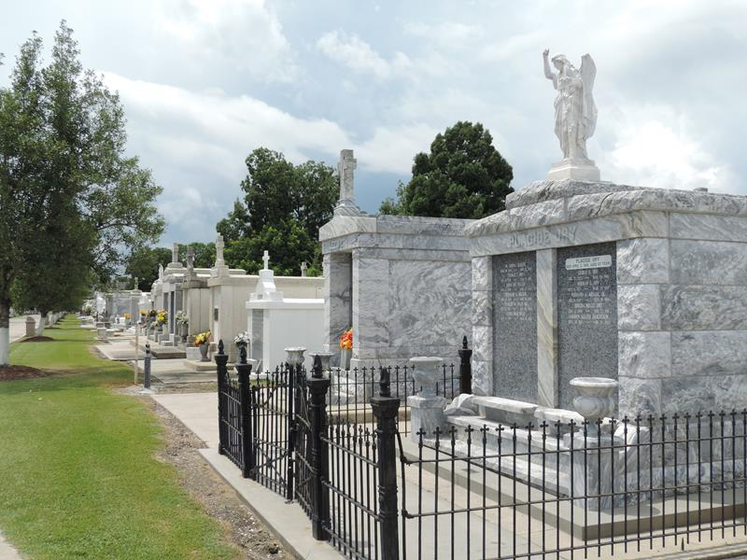

Wendy V. Galatas was born on November 18, 1955 and passed away on February 9, 2019. She was a lifelong resident of Reserve, LA.
Anyone that knew Wendy knew she was always full of laughter and could make anyone smile. She loved everyone around her with her whole heart. She was a devoted Saints fan.
She is survived by her husband of 30 years, Raymond Galatas; daughters, Vicki Mason (Phillip) and Katti Galatas; granddaughter, Sophia Mason; brother, Ricky Vicknair (Marie); mother- and father-in-law, Charles and Roseanna Galatas; brothers-in-law, Bobby Galatas (Denise) and Curtis Galatas (Tonia); and many nephews and nieces.
She was preceded in death by her parents, Roy and Earline Vicknair.
Visitation will be held on Wednesday, February 13, 2019 at 10 a.m. at St. Peter Catholic Church in Reserve, LA until a Mass of Christian Burial at 12 p.m. Burial will follow in the St. Peter’s Cemetery.

Rose Lynn Funeral Home, Lutcher, Louisiana

