William Clifton Galatas Sr.

October 4, 1925 – July 23, 1973

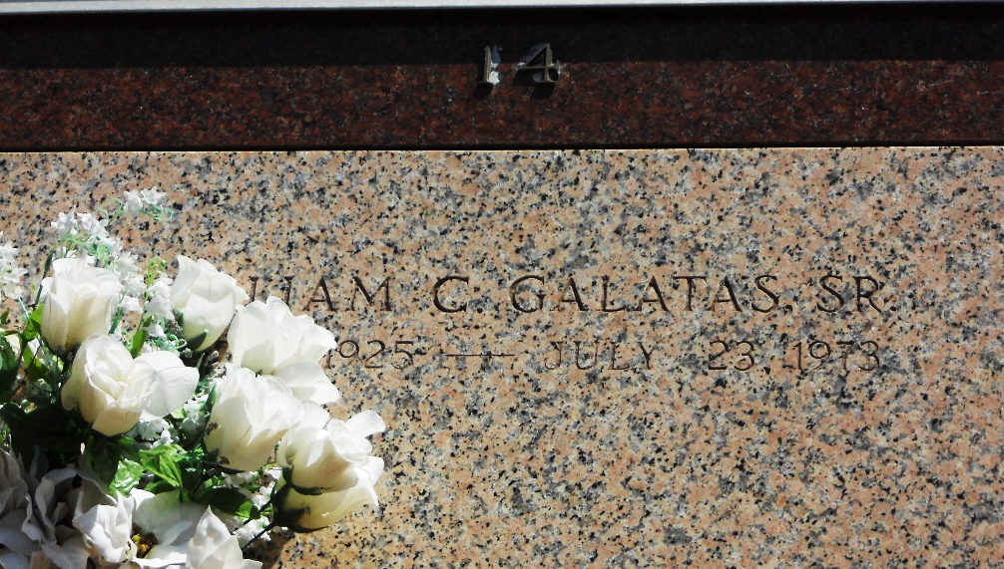

Photo by Team T-Lo

William (Skeet) Galatas Sr of St Rose, Louisiana, died Monday 23 Jul 1973 at 8:00 a.m. at age 47 years.

He was the husband of Lillie Chassion Sanchez and father of William Galatas Jr of Laplace, Louisiana, Mrs. Charles (Earline) Hammette of Zachary, Louisiana, Newton Galatas of Garyville, Louisiana, and Russell Galatas of St Rose, stepfather of Loretta Chassion and Gaynell Galatas and William Charles Galatas of St Rose. He was the brother of T J Galatas and Mrs. Wilson (Anna) Torres of Garyville, Charles Galatas of Reserve, Louisiana, and Mrs. Russell (Joyce) LeBeouf of Laplace. Also survived by 8 grandchildren. He was a native of Garyville and a resident of St Rose for the past 7 years.

The Times-Picayune, New Orleans, Louisiana

July 25, 1973