Joseph Thomas Garbin

May 12, 1932 - February 19, 2024

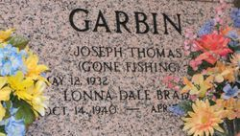

Photo by Team T-Lo

Joseph Thomas Garbin passed away on Monday, February 19, 2024 at the age of 91. He was born in Biloxi, MS and was a resident of Reserve, LA.  
 Beloved husband of the late Lonna Dale Garbin. Loving father of Kim Phillips (David). Son of the late Donna Pavlov Garbin and Grgur Garbin. Brother of George Garbin (Lora Lee) and the late Frank Garbin, Peter Garbin and Madeline Carpenter. Also survived by nieces and nephews.  
 Relatives and friends are invited to attend the Visitation and Funeral Mass at St. Peter Catholic Church, 1550 Hwy 44, Reserve, LA on Saturday, February 24, 2024. Visitation will be held at the church from 9:00 a.m. to 11:00 a.m. followed by a Funeral Mass at 11:00 a.m. Interment in St. Peter Cemetery, Reserve, LA.

Millet-Guidry Funeral Home, LaPlace, Louisiana

February 21, 2024