Lonna Dale (Brady) Garbin

October 14, 1940 – April 8, 2009

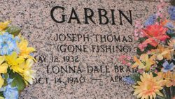

Photo by Team T-Lo

Lonna Dale Brady Garbin on Wednesday, April 8, 2009 at 9:15 pm after a courageous battle with cancer.

She was the beloved wife of Joseph Garbin for the past 49 yrs. She was the beloved mother & mother-in-law of Kim and David Phillips. She was the daughter of the late Eugene J. Brady and Minnie Weber Brady. She was the sister of late Ronald "Bubby" Brady and Arland Brady. She is also survived by 5 nieces and 1 nephew. Age 68 years. A native of Garyville and a resident of LaPlace.

Relatives and friends are invited to attend services. Visitation at Ascension of Our Lord Catholic Church, 1809 Greenwood Drive, LaPlace, La on Tuesday, April 14, 2009 from 9:30 am to 11:30am. Followed by a Mass of Christian Burial at the church at 11:30 am. Burial at St. Peter Cemetery, Reserve, La.

The Times-Picayune, New Orleans, Louisiana

Apr. 10, 2009