Joseph Garetino III
January 12, 1946 – January 8, 2017

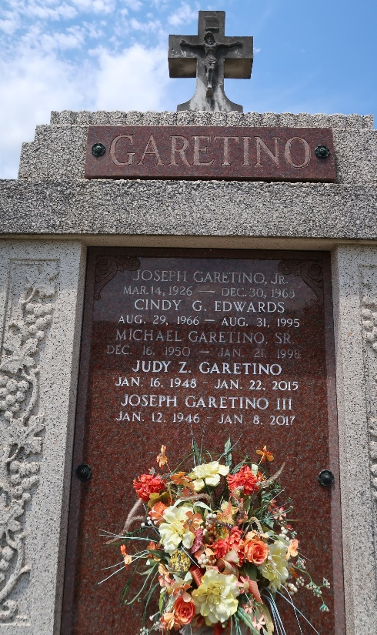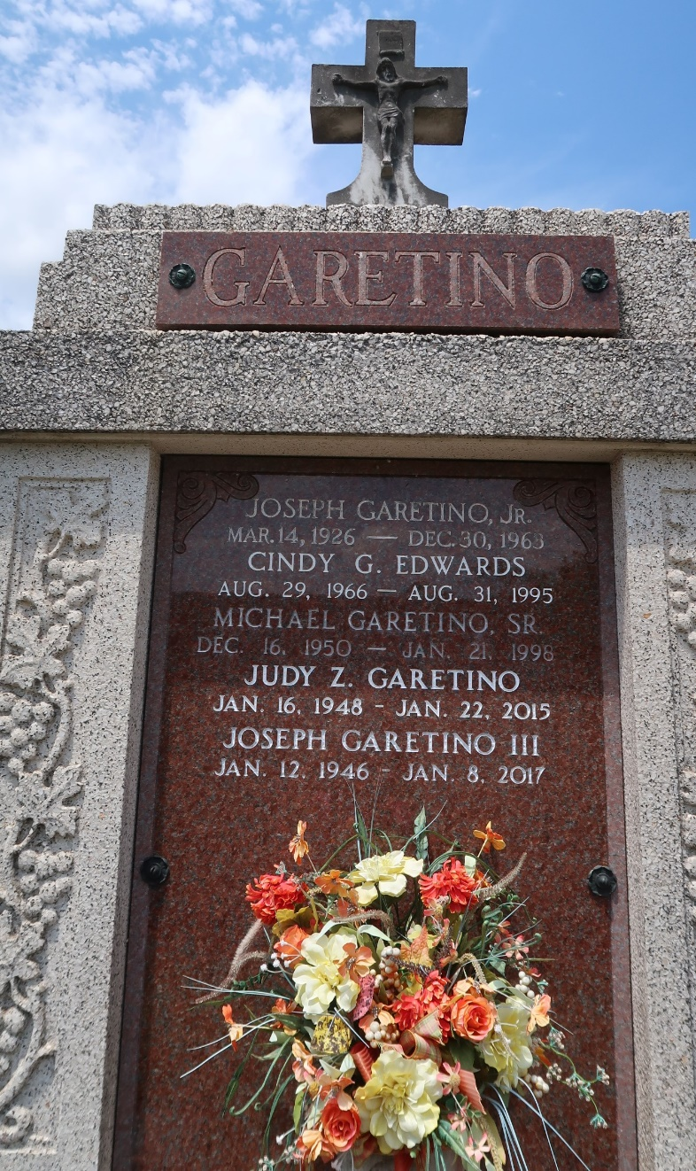

JOSEPH GARETINO, III age 70, passed away on Sunday, January 8, 2017. He was a native of Reserve, LA and a resident of Paulina, LA.
He is survived by his son, Kirt Garetino and wife Cathy and daughter, Connie Brunson and husband, Alan as well as a sister, Mary Griffin, 3 grandchildren and 1 great grandchild.
He is preceded in death by his wife, Judy Zeller Garetino; daughter, Cindy Edwards, brother, Michael Garetino, and parents Joseph and Angelle Garetino.
Visitation will be at Rose Lynn Funeral Services, 1870 Cabanose Ave., Lutcher, LA from 4:00 p.m. until 6:00 p.m. on Thursday, January 12, 2017. Burial will be at a later date. To sign and view the family guestbook, please visit www.roselynnfuneralhome.com

Rose Lynn Funeral Home, Lutcher, Louisiana

