Judith (Zeller) Garetino
January 16, 1948 – January 22, 2015

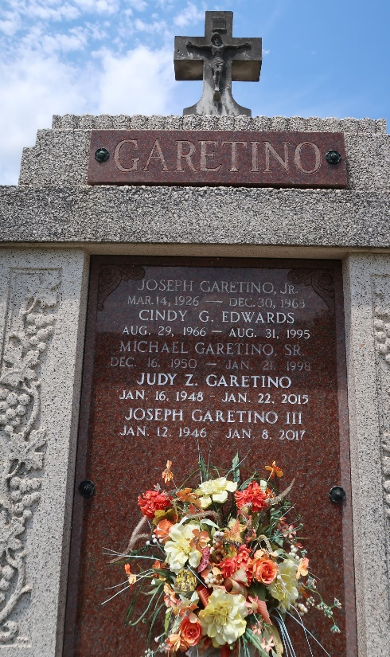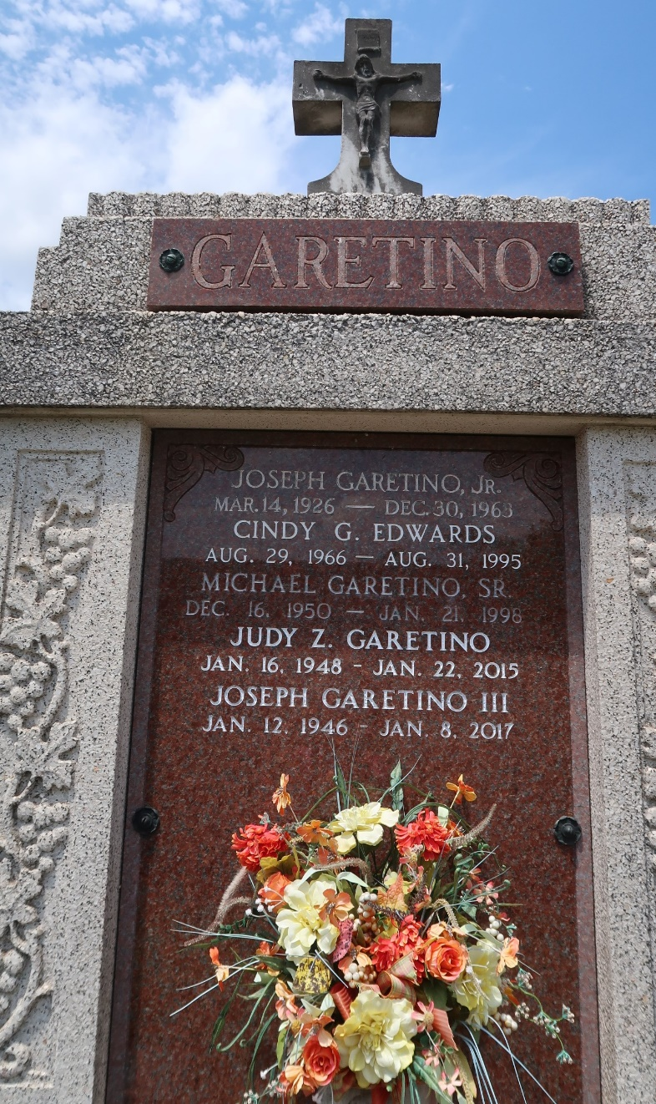

Judith "Judy" Zeller Garetino, age 67, passed away on January 22, 2015. She was a native of St. James Parish and a resident of Paulina, LA.
She is survived by her husband, Joseph Garetino; a son, Kirt Garetino; a daughter, Connie Brunson; brothers: Randy and Ruston Zeller, sisters: Cathy Borne and Tammy Golliday; 3 grandchildren and 1 great grandchild.
She was preceded in death by her parents Elliot H. and Pearl Roussel Zeller and a daughter, Cindy Garetino Edwards.
Visitation will be at Rose Lynn Funeral Home on Sunday, January 25, 2015, from 5:00 p.m. until 9:00 p.m. with a religious service at 7:00 p.m. in the funeral home. Cremation to follow. To sign and view the family guestbook, please visit www.roselynnfuneralhome.com.

The Advocate, Baton Rouge, Louisiana
Jan. 23 to Jan. 27, 2015

