Linwood Matthias Gauff
1950 – July 1, 2022

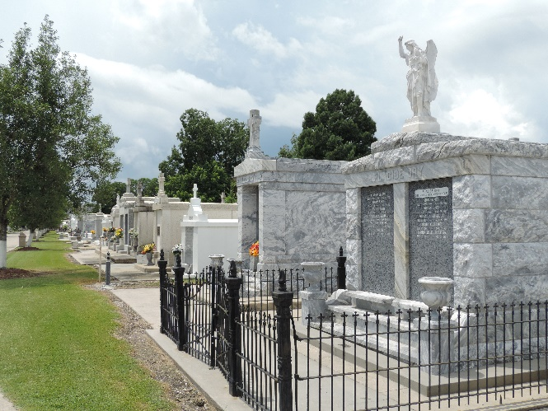

Linwood Matthias Gauff passed away on Friday, July 1, 2022, at the age of 72.
A native of Reserve, LA, son of the late Valsin and Myrtle Gauff and grandfather of the late Stone Colin. Father of Jermaine Gauff and Wyndi Gauff Colin (Shawn).
A U.S. Air Force and Vietnam Veteran, he is survived by his 7 siblings, Myrtle Ann Lucas, Sherin (Kenneth) Hill, LaJuana (Kenny) Chenier, Carey (Beverly), Milton, Duane, and Darwin Gauff. Also survived by 6 grand-children, 2 great-grandchildren, and a host of nieces, nephews, other relatives and friends.
Extended family and friends, also priest and parishioners of Our Lady of Grace Catholic Church and neighboring churches, are invited to attend the funeral Mass at Our Lady of Grace Catholic Church, 772 Highway 44, Reserve, LA, on Saturday, July 16, 2022, at 10:00 am, Very Rev. Godwin Ani S.S.J, Celebrant. Interment in St. Peter Cemetery, Reserve, LA. Visitation at the above-named church from 8:00 am until Mass time. Recitation of the rosary at 9:15 am.
The Times-Picayune, New Orleans, Louisiana
Jul. 13 to Jul. 16, 2022

