Lucien J. Gauff, Jr.
March 2, 1936 – February 1, 2025

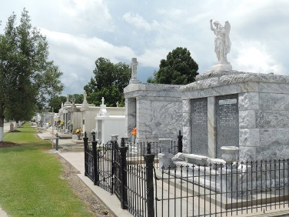

Lucien J. Gauff, Jr., a lifelong resident of St. John the Baptist Parish gracefully went to meet his Heavenly Father on February 1, 2025. Lucien (affectionately known as LJ), passed away peacefully at his home in LaPlace surrounded by his loved ones.
Born to Lucien Sr. & Velma White Gauff, Lucien Jr. was the eldest of five children. His siblings Larry (deceased), Lonnie, Lanelle (Jerome) and Lowell (Kat deceased) grew up as very close tightknit family in Garyville, La. He married the late Shirley Brown Gauff on June 24, 1961, his high school sweetheart, and they were married for over 38 years before her untimely death. Lucien graduated from Our Lady of Grace High School, as part of the first graduating class. While in high school, LJ started learning his trade with his dad, uncle and cousins. He later honed his craft by attending trade school and was deemed a master bricklayer. He was deemed “Louisiana’s Best Bricklayer”, his work is prominently featured throughout the state in landmarks like; The Superdome, Morial Convention Center, New Orleans Aquarium, Tulane Riley Center, Covenant House, malls, hospitals and countless projects throughout the state. His philanthropy was well known throughout the parish, he taught his craft in several trade schools in the area, provided jobs and provided his services on a multitude of projects in the community.
Lucien, Jr. was a man that loved God, his family and his community, he was always willing to help. He was a member of two Civic and Social clubs, The Twelve Ambassadors, Inc., chartered in 1968 and was a founding member of the Titans of Greater New Orleans founded in 1985.
Lucien is survived by his children Lucien III (Francesca), Errol (Medria), and Chermain Guerin (John deceased). His grandchildren; Cierra, Ciel, Sheridan, Tyson, Hailey and Cydney. His sister-in-law and bonus daughter Elmira Brown Duhe, her children, Tyra Duhe– Griffin (Jamaal) and Christina Duhe.
The family would like to invite the neighboring communities of the River Parishes and surrounding areas to a public visitation on Thursday, February 06, 2025 at Our Lady of Grace Catholic Church, 772 La-44, Reserve, La 70084 from 5:00-7:00pm. A Mass of Christian Burial will follow on Friday, February 07, 2025 at St. Joan of Arc Catholic Church, 529 W. 5th St., Laplace, La. 70068. Visitation begins for 9:30am with Mass to follow for 11:30am. Fr. David Ducote, officiant. Entombment St. Peter Catholic Church, 1550 La-44, Reserve, La. 70084.

Treasures of Life Funeral Services, Gramercy, Louisiana
February 6, 2025

