Myrtle Gabriel Gauff

April 11, 1925 – January 2, 2009

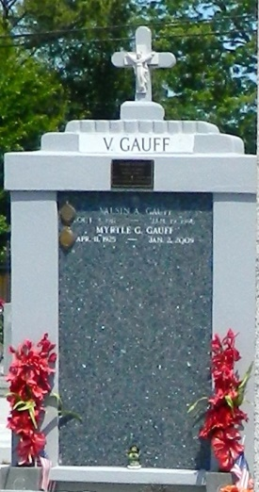

Myrtle Gabriel Gauff on Friday, Jan. 2, 2009, at Canon Hospice, Jefferson, La. Daughter of the late Alma Hayden. Wife of the late Valsin Gauff. Mother of Myrtle Ann Lucas, Sherin (Kenneth) Hill, LaJuana (Kenny) Chenier, Carey (Beverly), Milton, Linwood, Duane and Darwin Gauff. Sister of the late Irwin Davis. Also survived by 14 grandchildren, eight great-grandchildren and a host of nieces, nephews, other relatives and friends. Age 83 years. A native of Paulina and a resident of Reserve.  
  
Relatives and friends of the family, also priests and parishioners of Our Lady of Grace Catholic Church and neighboring churches, and employees of St. John Parish School Board, Xavier University, Mosaic Company, AB Clean, Divita Dialysis Center and Canon Hospice are invited to attend the Mass of Christian Burial at Our Lady of Grace Catholic Church, 772 Highway 44, Reserve, La., on Saturday, Jan. 10, at 11:00 a.m. Father Joseph Rodney, Celebrant. Interment St. Peter Cemetery, Reserve, La. Visitation at the above named church from 9 a.m. until Mass time. Recitation of the rosary at 10 a.m.

L'Observateur (La Place, LA) - Monday, January 12, 2009

Contributed by Jane Edson