Valsin Adam Gauff
1918 – January 1998

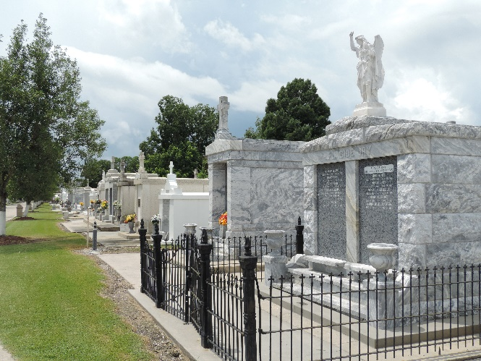

Valsin Adam Gauff, A Retired Self-Employed Bricklayer, Died Monday Of Respiratory Failure At Ochsner Foundation Hospital. He Was 80. Mr. Gauff Was A Lifelong Resident Of Reserve.
He Was An Army Staff Sergeant During World War II And A Member Of Bricklayers Local Union No. 1.
Survivors Include His Wife, Myrtle Gauff; Five Sons, Milton Gauff Of Atlanta, Darwin Gauff Of Laplace And Carey, Linwood And Duane Gauff; Three Daughters, Sherin G. Hill Of Holland, Mich., Lajuana G. Chenier Of New Orleans And Myrtle G. Lucas; 13 Grandchildren; And A Great-Grandchild.
A Mass Will Be Said Saturday At 11 A.M. At Our Lady Of Grace Catholic Church On River Road In Reserve. Visitation Will Begin Saturday At 9 A.M. Burial Will Be In St. Peter's Cemetery. Robottom Mortuary Is In Charge Of Arrangements.
The Times-Picayune, New Orleans, Louisiana
January 22, 1998

